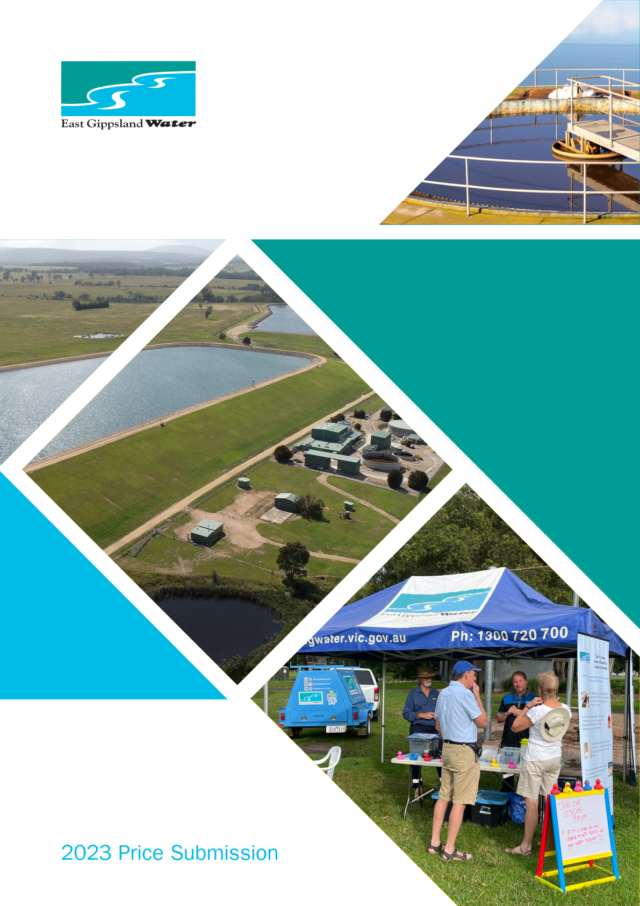

Acknowledgment
We acknowledge and respect the Gunaikurnai, Bidwell and Ngarigo Monero people as the Traditional Custodians of East Gippsland’s land and waters. We pay our respects to their Elders both past and present and emerging leaders.
We recognise and respect their unique cultural heritage beliefs, and intrinsic connection to Country, which continue to be important to them today. We have a strong commitment to further developing our relationships and partnerships with Aboriginal and Torres Strait islander peoples, communities and organisations.

Contents
Key messages 1
Board attestation 4
Message from the East Gippsland Water Customer Committee 5
1. Context 6
1.1 Storage deficit in dry periods 6
1.2 Ash run-off and flooding impacts to the environment in wet weather 7
1.3 Population growth 7
1.4 Ageing assets 7
1.5 Skills requirements 7
2. Performance 9
2.2 Delivery of customer outcomes 9
2.3 Operating expenditure 11
2.4 Capital expenditure 11
2.5 Customer sentiment 12
2.6 PREMO summary – Performance 13
3. Management 15
3.1 Price submission development process 15
3.2 PREMO summary – Management 17
4. Risk 19
4.1 Key risks and allocation summary 19
4.2 PREMO summary – Risk 24
5. Engagement 25
5.1 Overview 25
5.2 What we did 26
5.3 Matters covered by customer engagement 28
5.4 What customers told us 29
5.5 What we did with the feedback 29
5.6 PREMO summary – Engagement 30
6. Outcomes 33
6.1 Overview 33
6.2 Guaranteed Service Levels 33
6.3 Outcome 1: Reliable services, done well. 34
6.4 Outcome 2: Fair prices for all 35
6.5 Outcome 3: Improved environmental outcomes 37
6.6 Outcome 4: Prepared for population growth and a changing climate 38
6.7 Outcome 5: Contributing to community 39
6.8 Service standards 40
6.9 PREMO summary – Outcomes 41
7. Revenue requirement 43
7.1 Revenue requirement over 10-year period. 44
8. Forecast operating expenditure 45
8.1 Total and annual forecast operating expenditure 45
8.2 Baseline controllable operating expenditure 46
8.3 Operating expenditure savings 49
8.4 Operating expenditure increases 50
8.5 Annual cost efficiency improvement rate 51
8.6 Allocation of corporate costs 51
9. Forecast capital expenditure 52
9.2 Summary of capital expenditure program 52
9.3 Major capital projects 54
9.4 Capital programs and other capital expenditure 59
9.5 Method for developing the capital expenditure program 61
9.6 Cost efficiencies 62
9.7 Capacity to deliver 62
10. Return on the regulatory asset base 65
10.1 Forecast regulatory asset base 65
10.2 Forecast RAB until 2032/33 66
10.3 Regulatory depreciation 66
10.4 Government contributions 66
10.5 Gifted/donated assets 66
10.6 Customer contributions 67
10.7 Cost of debt 67
10.8 PREMO rating and the regulated return on equity 67
11. Tax allowance 68
11.1 Price submission tax rates 68
11.2 Income tax estimate 68
12. Demand 69
12.1 Method 69
12.2 Growth rates 69
12.3 Demand calculations 70
12.4 Price elasticity of demand 70
12.5 Demand management 70
12.6 Incorporating demand into operational budgets 71
13. Form of price control 72
14. Prices and tariff structures 73
14.1 Water tariff 73
14.2 Wastewater tariff 73
14.3 Trade waste tariff 74
14.4 Recycled water tariff 75
14.5 Fire services availability charge 75
14.6 Supply by agreement customers 75
14.7 Miscellaneous services 75
15. Adjusting price 78
16. New customer contributions 79
17. Financial position 80
Appendix A: Outcome measures and targets 81
Appendix B: Guaranteed Service Levels 82

Document status
Rev No | Comments | Issue Date | Reviewed By
1 | Preliminary draft | 9 August 2022 | Executive and Board
2 | Draft | 5 September 2022 | Customer Committee
3 | Final draft | 13 September 2022 | Executive and Board
4 | Final | 28 September 2022 | Executive Team

Key messages
At a glance:
- Five-year regulatory period.
- 0.30% increase to average customer bills (beyond CPI).
- Increased support for customers experiencing hardship (by $100,000 to a total of $250,000 per year).
- $115 million capital works proposed over five years.
- $127 million operating expenditure over five years.
- Five refreshed outcomes that customers value.
- Efficiency measures that deliver a reduction in operating costs from the baseline year of 0.75% per year (excluding above baseline opex requirements).
- ‘Individual price cap’ form of price control, with the exception being a ‘tariff basket’ price control for major trade waste tariffs.
- A prudent and efficient Price Submission that provides the best value for customers.
- Standard PREMO rating.

Over the last five years, we have faced a unique combination of unprecedented challenges in East Gippsland, including severe drought, devastating Black Summer bushfires, significant wet periods, and the COVID-19 pandemic. These events have challenged us operationally and at the same time shaped the way we think about the future of water for our region and communities.
We must assume that such significant variations in climate are going to be typical of the future and prepare accordingly. The time to act is now. Waiting is not an option.
This Price Submission is our best offer to customers to ensure we can continue to deliver our core water and wastewater services at existing service levels in the context of the significant challenges we face. Those challenges and how we plan to address them include:
- Adapting to a changing climate – by securing more water for our region and communities through investing in additional water storage.
- Improving environmental outcomes – by upgrading wastewater treatment networks and plants to cope with more intense rain events and protect the environment. We are also continuing on our path to meet net zero emissions by 2035.
- Responding to growing communities – by upgrading water and wastewater networks to meet growth and demand, which has continued with regional migration.
- Upgrading ageing assets – by investing more to ensure regulatory compliance and to maintain the levels of service valued by our customers.
The foundations of this plan, for a five-year regulatory period, are built on an understanding of our customers’ needs and values. Our engagement program for this Price Submission began in earnest early 2021 and has gained comprehensive input from more than 900 customers (about three per cent of our customer base) through surveys, face-to-face conversations, and a customer forum.
This level of engagement reflects the positive relationship we have with our community, particularly given the impacts of COVID-19 and trauma many still experience following the bushfires.
Our engagement revealed that customer expectations still largely align with our existing customer outcomes around affordability, getting the basics right, environmental sustainability, liveability, and being part of the community. In addition, key messages from our customers, regulators and stakeholders, along with consideration of our current risk profile, identified the emerging challenges of water security, climate change and environmental compliance, as issues we need to address.
This resulted in five revised key outcomes our customers will receive during the 2023-28 period. They are:
- Reliable services, done well.
- Fair prices for all.
- Improved environmental outcomes.
- Prepared for population growth and a changing climate.
- Contributing to community.
The activities and programs proposed to achieve these outcomes will require an investment of $115 million in capital works over the regulatory period.
Our operating expenditure for the 2023-28 regulatory period is forecast to be $127 million, including an increase from baseline expenditure of $9 million over the period.
These expenditure increases will result in a price rise to average residential customer bills of 0.30% above CPI during the regulatory period. A summary of the impact of this submission on our average customers’ bills is presented below in Table 1:
Table 1: Forecast average bill impacts excluding CPI per annum (based on CPI + 0.30%)
 | 2022/23 | 2023/24 | 2024/25 | 2025/26 | 2026/27 | 2027/28
Residential | $1,238 | $1,241 | $1,245 | $1,249 | $1,252 | $1,256
Tenant | $ 334 | $ 335 | $ 336 | $ 337 | $ 338 | $ 339
Non-residential | $3,271 | $3,281 | $3,291 | $3,300 | $3,310 | $3,320
Vacant Land | $ 465 | $ 467 | $ 478 | $ 469 | $ 471 | $ 472

We propose an ‘individual price cap’ form of price control in the 2023-28 regulatory period as per the 2018-23 period. The exception being our proposal to introduce a ‘tariff basket’ form of price control for major trade waste tariffs. ‘Individual price cap’ price control provides customers with greater price certainty and is easier to administer and explain.
Extensive work has been undertaken to understand the cost of providing trade waste services to our major customers. We propose introducing a ‘tariff basket’ for major trade waste customers to allow tariff reform throughout the 2023-28 regulatory period, once internal processes are improved and customer engagement has been undertaken.
Using guidance provided by the Essential Services Commission, we have assessed our overall submission to be ‘standard’ under the PREMO incentive mechanism, with an aggregated score of 12.1/20, as presented below in Table 2.
Table 2: PREMO self-assessment overall outcome summary
PREMO ELEMENT | East Gippsland Water’s SELF-ASSESSMENT
Performance | Standard (2.44/4)
Risk | Standard (2.5/4)
Engagement | Standard (2.71/4)
Management | Standard (2.2/4)
Outcomes | Standard (2.25/4)
Overall PREMO rating | Standard (12.1/20)

Our customers, Board, managing director, executive team, subject matter experts and other staff across our business have been central to the development of this submission. At the highest level, our Board has attested that our submission meets the Essential Services Commission’s requirements and addresses all elements of PREMO.
The submission has also been endorsed by our Customer Committee.

Board attestation
The directors of East Gippsland Water, having made such reasonable inquiries of management as we considered necessary (or having satisfied ourselves that we have no query), attest that, to the best of our knowledge, for the purpose of proposing prices for the Essential Services Commission’s 2023 water price review:
- information and documentation provided in the price submission and relied upon to support East Gippsland Water’s price submission is reasonably based, complete and accurate in all material respects;

- financial and demand forecasts are the business’s best estimates, and supporting information is available to justify the assumptions and methodologies used; and

- the price submission satisfies the requirements of the 2023 water price review guidance paper issued by the Essential Services Commission in all material respects.

Therese Tierney
CHAIRPERSON
EAST GIPPSLAND WATER

Message from the East Gippsland Water Customer Committee
The development of East Gippsland Water’s Price Submission (PS2023-28) has been extensive and the Customer Committee is appreciative of its involvement along the journey. Of particular note is the East Gippsland Water has used a rigorous process to ensure that the engagement for the upcoming Price Submission was been universal and inclusive.
Customers were provided with a multitude of opportunities to participate, across different towns, and via different methods for around 18 months. COVID-19 restrictions impacted part of the engagement journey, with the Corporation defaulting to using online methodology when restrictions prevented face-to-face interaction. Staff also showed their enthusiasm for the process, embracing opportunities for in-person engagement and consultation the moment restrictions were eased.
By attending the deliberative forum in an observation capacity, Customer Committee members were able to gain assurance that customers genuinely helped design the process and set the agenda.
Following the IAP2s public participation spectrum methodology, the engagement revealed that customer expectations still largely align with our existing customer outcomes around affordability, getting the basics right, environmental sustainability, liveability, and being part of the community.
Whilst Customer Committee members were an integral part of the journey, we wish to acknowledge the tremendous efforts of East Gippsland Water staff at all levels who have been central to the development of this submission.
Committee members attest this has been a robust process from the ‘exploration stage’ to ‘closing the loop’. We believe the outcome is fair and transparent and will resonate with the customer base. The engagement findings will also be a valuable reference source for the Customer Committee in its future deliberations.
Thank you again to everyone involved and we commend this to the Board for consideration.
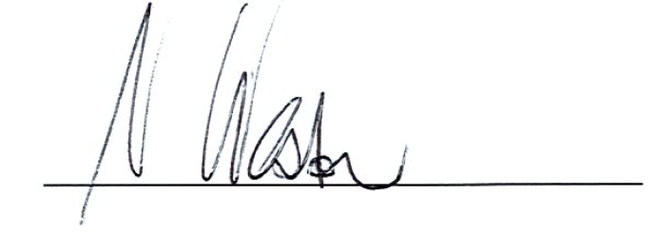
Noel Weston
CHAIRPERSON
EAST GIPPSLAND WATER CUSTOMER COMMITTEE

- Context
At a glance:
- Driest period on record in East Gippsland from 2017 to 2019.
- Wettest year on record in East Gippsland in 2021.
- 56% (over one million hectares) of East Gippsland burnt in 2019-20 Black Summer bushfires, including eight out of nine drinking water catchments.
- The climate has changed and we expect this to continue, meaning higher temperatures, less but more intense rainfall, and reduced river flows.
- A substantial step-up in capital expenditure is required to respond to climate change.
- The time to act is now.

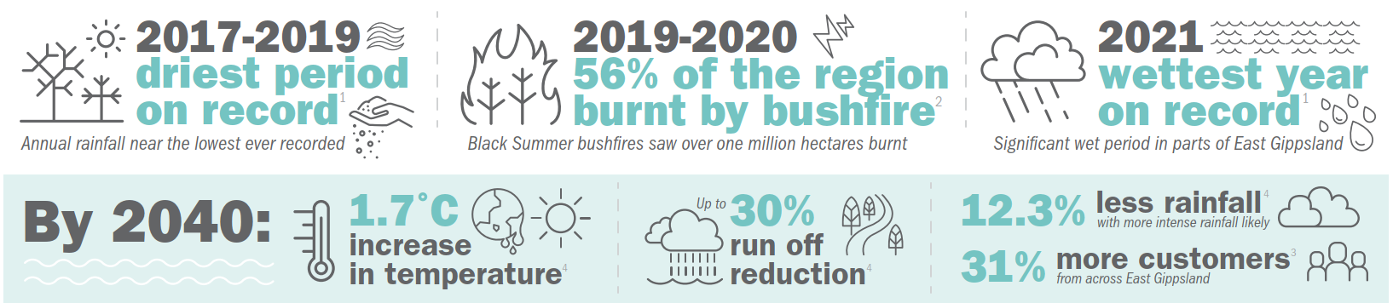
Figure 1: East Gippsland regional snapshot¹⁻⁴
This price submission has been developed in the context of five years of unique and unprecedented challenges in East Gippsland. The reality of climate change and increasing climate variability are now at the forefront of our minds as we have experienced some of our most difficult years on record. Three years of debilitating drought led to the 2019-20 Black Summer bushfires which devastated our region, burning more than one million hectares or 56% of East Gippsland².
Shortly after, the impacts of the COVID-19 pandemic emerged; hampering recovery efforts and leading to an increase in people moving to this beautiful part of Victoria.
At the same time, we experienced a significant wet period, including the wettest year on record in 2021 which has continued into 2022¹ and resulted in 14 controlled emergency discharges from our treatment plants into the environment as at August 2022⁵.
The extremes of drought, bushfires and flooding are not hypothetical far-off future risks as predictions in 2017 suggested, they have been our lived experience in the last five years. Climate variability and unpredictability must be at the core of our planning to ensure we continue to deliver the essential water and environmental services expected by our customers and stakeholders. We must take action now.
Below is further detail on the context that underpins our proposals in this Price Submission:
  - Storage deficit in dry periods
East Gippsland has historically benefited from very reliable river flows. This has meant that in the past we only needed to store a few months of water to get us through the summer, with water harvested from rivers as needed to keep storages full.
However, the driest period on record from 2017-2019 resulted in all rivers in East Gippsland flowing at their lowest recorded levels. During this time, the Mitchell River, which supplies around 83% of our customers, had effectively ceased to flow and our modeling indicated the Mitchell system may have only 60 days of water left by late February 2020.
Fortunately, we received welcome rain and river flows began to recover. Considering this experience and the climate change scenarios used for developing our 2022 Urban Water Strategy, it is clear that we have an immediate storage deficit based on levels of service agreed with our customers. Following extensive consultation with customers and key stakeholders, it has been determined that we need a third water storage at our Woodglen Water Treatment Plant site⁶.
  - Ash run-off and flooding impacts
Although the rain came at a critical time in February 2020 and the Black Summer bushfires eventually abated, we faced a further challenge as eight out of our nine drinking water catchments were impacted, with five severely impacted (over 70% burnt). The run-off from the burnt catchments carried ash, soil and organic matter into our rivers and resulted in a water quality event that lasted for the next six months.
This was followed with the wettest year on record in 2021 in East Gippsland, based on Bureau of Meteorology records from the Bairnsdale Airport weather station. The wet conditions continued into 2022¹.
This period of wet weather flooded our wastewater networks and treatment plants. At several plants, the flooding overwhelmed treatment and irrigation capacity and we had no choice but to make controlled releases of treated wastewater to local streams to protect assets, property and the environment. These discharges highlighted the need for upgrades to our facilities to protect our environment, meet increasing customer demand, and to address the impact of more intense wet weather conditions.
Our Price Submission therefore includes a number of wastewater network, treatment and irrigation capacity upgrades. This includes major upgrades at our Paynesville, Bairnsdale and Bemm River Wastewater Treatment Plants.
  - Population growth
Growth in our region has continued over the last five years and increased further due to recent regional migration. The increase in population, particularly around Bairnsdale and seaside townships such as Lakes Entrance and Paynesville, means that existing assets are no longer capable of meeting our levels of service in some areas.
  - Ageing assets
In addition, we have a number of ageing assets that were built decades ago and not designed to withstand the current changes to the climate. We knew we were approaching the time to replace these ageing assets, but climate variability and growth have put unprecedented pressure on our systems and the need to upgrade is now more urgent.
  - Skills requirements
Extreme weather events have put immense pressure on our business in terms of emergency response over the last five years. There is a need to invest in more people, more training and increasing the resilience of our assets.
We ask the ESC to keep the context outlined in this chapter, and the unique combination of extreme challenges we have faced, at the forefront of its mind while reviewing our proposals in this Price Submission.

Key references relating to this chapter:
- Bureau of Meteorology Climate Data Online - Map search (bom.gov.au)
- East Gippsland Regional Catchment Strategy Home | East Gippsland Regional Catchment Strategy (rcs.vic.gov.au)
- EGW Growth Projections Master - DOC/16/2886[v3]
- Guidelines for Assessing the Impact of Climate Change on Water Availability in Victoria, DELWP, November 2020
- History of Emergency Discharges 2021-2022 – DOC/22/23238
- Urban Water Strategy 2022 - DOC/22/5483

- Performance
At a glance:
Performance across the previous period has been very strong in spite of the significant challenges we have faced, with overall customer outcomes met or largely delivered each year.
Operational expenditure is approximately nine per cent or $1.80 million higher than approved for the Price Submission 2018-23 baseline year.
Capital expenditure is forecast to be approximately five per cent or $3.57 million lower than approved in Price Submission 2018-23.
Four of the 2018-23 Top 10 projects have been delivered, two are on schedule, three have been delayed and one deferred (re-prioritised to the next price period).
Customer sentiment demonstrates high levels of satisfaction with our performance and indicates they feel we provide a quality service that is value for money.
Our PREMO self-assessed rating for performance = Standard (2.44/4).

Despite facing significant challenges in the 2018-23 price period, our performance has remained very strong and our customers have continued to receive a quality service that is value for money.
Our performance was impacted by the catastrophic bushfires that hit our region after the driest period on record, the COVID-19 pandemic, and the wettest year on record in East Gippsland. These challenges impacted our performance against customer outcomes, operational expenditure and capital expenditure.
  - Delivery of customer outcomes
Our overall performance against our customer outcomes has been very strong. This has resulted in us rating our overall performance for the 2018-23 period to date as green (targets met) against four out of five outcomes¹. This has been endorsed by our Customer Committee².
Throughout the period we prioritised the continuity of essential services and the provision of bespoke support solutions for our customers. We also delivered one of our largest capital investment programs in order to maintain the high levels of service our customers expect.
A summary of our performance to date for the 2018-23 period to date is shown in Table 3, below.
Table 3: Performance against outcomes summary
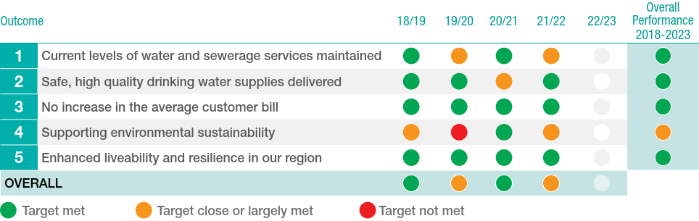
Outcomes performance summary:
- The traffic light scores for each outcome are endorsed by our Customer Committee annually.
- Our performance across the period has been very strong, with overall customer outcomes met in the majority of years. This has resulted in our overall rating of green (targets met) against four of the five customer outcomes, which has also been endorsed by our Customer Committee.
- Our overall performance for outcome four, supporting environmental sustainability, has been rated as yellow (largely met). This is mainly due to falling short of our target for native vegetation grants. Following consultation with our Customer Committee, this outcome has been revised for the 2023-28 period and will become a $90,000 annual contribution to a water efficiency rebate program (see Chapter 6).
- Measures are put in place to address any deficiencies and ensure we continuously strive to meet our commitments to customers, as outlined in the annual Outcomes Performance Reports to the ESC.
- We have also delivered on our Guaranteed Service Levels over the period as summarised in Table 4.
Table 4: PS 2018-23 Guaranteed Service Level Performance Overview
 | Service area | Guaranteed Service Level | 2018/19 | 2019/20 | 2020/21 | 2021/22 | 2022/23
1 | Bill payment difficulties | We will not restrict a residential customer’s water supply or take legal action against the customer before all reasonable efforts have been made to contact them and provide information about help available if they are experiencing difficulties. *  If East Gippsland Water fails to do this, a rebate of $300 will be applied to the customer’s bill. | Compliant | Compliant | Compliant | Compliant | -
2 | Sewage spills | In the event of a sewage spill within a customer’s house, which is caused by us, there will be a $1,000 cash payment to the home-occupier affected. | 3 x $1,000 | 3 x $1,000 | 1 x $1,000 | 1 x $1,000 | -
3 | Planned interruptions to water supply | Will notify customers of planned interruptions to their water supply at least 48 hours in advance. If the organisation fails to do this, a rebate of $65 will be applied to the bills of affected customers. | 106 x $65 applied to bills | - | 2 x $65 | - | -
4 | Planned interruptions to water supply | If a planned water supply interruption exceeds the period specified in the notice, affected customers will have a $65 rebate applied to their bill. | 43 x $65 applied to bills | 1 x $65 applied to bill | - | - | -
5 | Environmental Sustainability | We are striving for a 21% reduction in greenhouse gas emissions by 2025 and will provide a six-monthly update on progress to the community. There will be a written public apology if this update is not provided. | Updates provided | Updates provided | Updates provided | Updates provided | -
6 | Environmental Sustainability | We have committed $90,000 each year from 2018-2023 to support local schools and community groups with grants for native vegetation planting and habitat creation projects across the East Gippsland region.  The allocation of funds for this project will be reported on at least annually. Any unspent money will be safeguarded for use only on the program. | $72,000 allocated for year  Updates provided | $60,429 allocated for year  Updates provide | $108,771 allocated for year  Updates provided | $37,356 allocated for year  Update provided | -  -
*As defined by the Essential Services Commission
  - Operating expenditure
Our operational expenditure for the current period is approximately nine per cent or $1.80 million higher than approved for the 2018-23 Price Submission baseline year. This is due to variances we have incurred, including:
- A shift in priorities due to bushfires, COVID-19 response, wet weather, and trade shortages.
- Additional staffing to respond to increasing compliance requirements on water corporations (Asset Management Accountability Framework, Public Construction Procurement, Gender Equality etc.) and to manage increasing emergency management responses due to climate variability.
- Increases in remuneration to ensure skilled staff are retained and attracted to the business.
- Increase in consultant expenditure to deliver asset management improvements.
- Insurance market hardening leading to increased insurance premiums.
- Chemical usage increases to address water and wastewater quality requirements.
- Lower electricity costs than forecast due to better market outcomes than included in our submission.
  - Capital expenditure
Actual capital expenditure is forecast to be approximately $65.74 million, this is approximately five per cent or $3.57 million lower than approved in Price Submission 2018-23.
Four of the 2018-23 Top 10 projects have been delivered, two are on schedule, three have been delayed and one deferred (re-prioritised to the next price period). Our overall performance has been impacted by:
- Drought followed by major bushfires, impacting staff, resources and resulting in re-prioritisation of projects in response.
- COVID-19 – restrictions which led to difficulties getting contractors onsite, resulting in delays and backlog of projects.
- Delays and availability in the plant and materials supply chain.
- Market conditions that saw a shortage of labour resulting in increased competition and rising prices, fewer bidders on tenders, and higher project input costs such as fuel and materials.
- Major change of external engineering services provider (establishment of two-tiered panel approach).
- Delivery of unplanned bushfire recovery works and third-party schemes, both providing benefits to local communities.
Table 5: Top 10 Projects Summary
Project | Status | Comments
Wy Yung clear water storage | Complete | Project completed on time in 2020-21.
Paynesville recycled water storage and irrigation augmentation | Delayed | Significant change in scope due to increased growth and plant inflows, which has resulted in a need for greater storage capacity. This has delayed the storage works. Irrigation expansion on track to be completed in 2022-23. The construction of a 300ML (approximate) recycled water storage and pump stations is now also a Top 10 project for the 2023-28 period See chapter 11).
Upgrade main supply pipeline (Sarsfield to Johnsonville) | Complete | Project completed on time in 2019-20.
Sarsfield clear water storage augmentation | Complete | Project completed in 2021-22. Minor defects rectification in process.
Woodglen raw water storage – dam safety upgrades | On schedule | On schedule for completion in 2023-24.
Bairnsdale to Eagle Point main supply pipeline renewal | Complete | Project completed on time in 2021-22.
Mallacoota clear water storage | On schedule | Tendering will be completed in 2022, with construction to commence in the first half of 2023. Some construction may carry-over into 2023-24.
Dinner plain recycled water storage augmentation | Deferred | Design of 14ML new winter storage basin is in progress. Construction has been deferred to enable the completion of some sewer network infiltration rectification works. These works may reduce the volume of winter storage required.
Lindenow storage water quality improvement | Delayed | Scope increased to allow for additional tank volume based on a revision of the system demands. Proposed tank location relocated from Woodglen WTP to the Lindenow Basin site. Construction will likely be delayed until 2023-24.
Lakes Entrance wastewater treatment plant odour management | Delayed | Stage 1 of this project was completed in 2018-19 which significantly reduced odour levels. Stage 2 of the project is on track to be completed in 2022-23.
  - Customer sentiment
Overall, customer sentiment across the current five-year price submission period demonstrates high levels of satisfaction with our performance, and indicates that customers feel that we provide a quality service that is value for money. This is supported by the results of our Annual Customer Satisfaction Survey and our performance in the ESC’s Quarterly Customer Perception Survey.
The key outcomes from our 2021 Annual Customer Satisfaction Survey³ of 400 people were:
- 76% of customers said they receive value for money from EGW.
- 67% of customers said EGW is a valued member of the local community.
- Customers have high levels of trust in EGW.
- 88% of customers were satisfied with the quality of EGW’s drinking water.
- 94% of customers said EGW is easy to deal with.
- 65% of customers were aware of EGW’s hardship program.
- 89% of customers said they get the right amount of information from EGW.
- Customers rated EGW a 4.3 out of 5 for overall satisfaction.
These results demonstrate that we are well regarded in the community despite the challenges we have faced.
The ESC’s Quarterly Customer Perception Surveys across the five years from 2018-2022 also show that we consistently rank among the top water corporations (for value for money, level of trust, reputation in the community and overall satisfaction) and historically ahead of the statewide average⁴.
In the final weeks of preparing this Price Submission, the ESC’s latest Quarterly Customer Perception Survey results were released. These results showed a decline in our rankings. While we can only speculate at this point the reasons for the drop off (which appears to be a trend across all water businesses except for Wannon Water), we look forward to comparing the results to our 2022 Annual Customer Satisfaction Survey of 400 people in the coming months.
  - PREMO summary – Performance
For the performance component of PREMO, we assessed ourselves to be standard (2.44/4), as summarised in Table 6.
Table 6: Performance PREMO assessment
Aspect | Score | Comment
To what extent has the business demonstrated delivery of its customer outcomes commitment over the current regulatory period? Did its customers get what they paid for? | 3 | Generally delivered on our commitments by meeting our performance targets for most output measures across the regulatory period. Overall rating of green (targets met) against four of the five customer outcomes¹, which has also been endorsed by our Customer Committee².
How does actual operating expenditure across the current period compare with the established benchmark allowance, and to what extent has the business rationalised any discrepancies? | 2 | Actual controllable expenditure is forecast to be 9% higher than the allowance included in the final Price Submission 2018-23 decision. The increased controllable expenditure is due to a shift in priorities due to bushfires, COVID-19 and wet weather, as well as additional staffing to respond to increasing compliance obligations and an increase in consultant expenditure to deliver asset management improvements.
How does actual capital expenditure across the current period compare with the established benchmark allowance, and to what extent has the business rationalised any discrepancies? | 2 | Overall capital expenditure is forecast to be approximately five per cent or $3.57 million lower than approved in Price Submission 2018-23.  Major capital program has not been fully delivered, including delays/deferral of four of the top 10 projects. The capital program delivery has been impacted by a number of factors including drought and bushfires, COVID-19, market conditions and delays in the availability of plant and materials. We have still delivered our largest capital program, including a number of unplanned bushfire recovery projects.
To what extent does customer sentiment demonstrate satisfaction in the business’s performance over the current regulatory period? Are customers happy with the value they receive from their water business? | 2.75 | We have historically scored above the statewide average in the ESC’s quarterly customer perception survey and our Annual Customer Satisfaction Survey’s demonstrates our customers overall satisfaction with our services and value for money.
Overall average score | 2.44 | Standard

Key references relating to this chapter:
- EGW Price Submission Scorecard – DOC/22/43684[3]
- Customer Committee Minutes (1 August 2022) – DOC/22/47064
- Annual Customer Satisfaction Survey & Price Submission 2023 Preferences Findings Summary Report – DOC/22/3615
- ESC’s Quarterly Customer Perception Surveys - https://www.esc.vic.gov.au/water/sector-performance-and-reporting/how-customers-rate-their-water-business
- Management
At a glance:
This Price Submission was informed by internal strategies developed for all areas of our business.
The Board, executive and senior management, Customer Committee and wider customer base all played a significant role in developing the submission.
The submission has been approved by the Board and endorsed by the Customer Committee.
All operating expenditure above the 2021/22 baseline was validated by risk-based prioritisation and executive reviews.
All capital expenditure proposals were subjected to a robust review and prioritisation process.
Key outcomes and service levels were developed through rigorous and wide-reaching customer engagement.
Our cost efficiency improvement rate of 0.75% demonstrates our prudent and efficient management.
Our PREMO self-assessed rating for management = Standard (2.2/4).
  - Price submission development process
Our 2023-28 Price Submission was developed with input from our Board, executive and senior management, subject matter experts (internal and external), our Customer Committee, and our broader customer base. This is our ‘best offer’ to our customers for the achievement of our five outcomes and their associated measures and targets over the next regulatory period.
The Board; the Infrastructure, Operations and Environment (IOE) Sub-committee; and Strategy Sub-committee and independent Customer Committee have been actively involved in the development, review and approval of the Price Submission^{1, 2}.
Strategy development
In 2020, our executive team tasked senior management with developing new strategies for all areas of our business operations. These became key references that informed our 2023-28 Price Submission.
A Price Submission Executive Steering Committee was also established to oversee all aspects of the Price Submission development including customer and stakeholder engagement and strategy development.
The strategies followed a standard template to ensure customer, regulatory, strategic and operational risks and key assumptions were identified and addressed.
They were informed by regulatory guidance such as the Statement of Obligations and advice from the Department of Health and the revised Environment Protection Act. They were also informed by extensive community engagement and incorporate initiatives and action plans to deliver agreed outcomes valued by customers. The strategies were then used to build the operating expenditure forecast for the regulatory period, with executive level review to further validate recommendations³ (see Chapter 8).
Briefing program
A comprehensive program of papers and briefings was provided to the Board and relevant sub-committees during the development of the Price Submission. This process started with the development of the strategy framework⁴, Price Submission pathway¹ and the expansion of our strategic objectives into a set of principles¹. These principles captured the Board’s expectations and considerations for the business to address in our internal business strategies and Price submission development.
Table 7 presents a summary of papers prepared in relation to the Price Submission for the Board and sub-committees over the past four years.
Table 7: Number of papers prepared for Board and sub-committees 2019-2022²
 | 2019 | 2020 | 2021 | 2022 | Total
Price Submission process development and progress updates | 3 | 10 | 7 | 3 | 23
Customer engagement program development | 0 | 3 | 3 | 5 | 11
PREMO framework | 0 | 0 | 5 | 0 | 5
Opex, capex and pricing | 0 | 1 | 2 | 6 | 9
Attestation | 0 | 0 | 0 | 2 | 2
Total papers prepared for Board, IOE & Strategy Committees | 3 | 14 | 17 | 16 | 50

Members of the Board and Customer Committee also attended our customer Deliberative Forums as observers of the process.
This extensive involvement gives us confidence this Price Submission provides value for money to customers, while delivering key outcomes and maintaining our relatively high service levels. We believe we have struck the balance between keeping prices low and bills affordable to our customers with being able to deliver our core business of providing high quality and reliable water and wastewater services.
Our capital expenditure proposals have involved detailed justification and have been subject to rigorous review and prioritisation including risk-based workshops⁵ (see Chapter 9).
Figure 2 shows a summary of the Price Submission development process. This process was iterative, with feedback from the community, executive, Board, regulators and results of key technical reports and business cases incorporated along the way.
Further detail relating to the Price Submission development process can be provided on request.
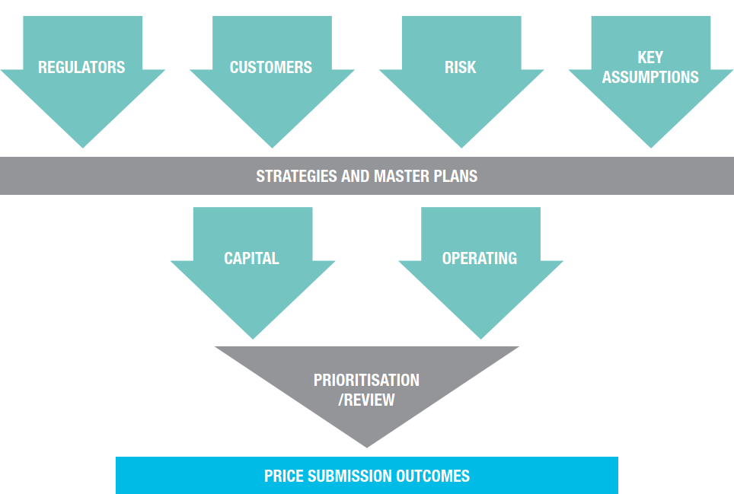
Figure 2: Overview of our Price Submission development process
  - PREMO summary – Management
Workshops involving the executive leadership team and key staff were held in during July and August 2022 to self-assess our PREMO rating for ‘management’⁶. This provided a further level of scrutiny to our Price Submission.
For the management component of PREMO, we assessed ourselves to be standard (2.2/4), as summarised in Table 8.
Table 8: Management PREMO assessment
Aspect | Score | Comment
To what extent has the business demonstrated how its proposed prices reflect only prudent and efficient expenditure? | 2 | We have committed to an average efficiency saving of CPI minus 0.75% on controllable costs per annum.  Operating and capital expenditure proposals have involved detailed justification and have been subject to rigorous review and prioritisation including risk-based workshops^{3, 5}.  Successive reviews by our executive and Board assessed and validated key projects².  We have prudently programmed uncertain works by extending some outside the regulatory period and smoothed out high cost programs such as desludging.
To what extent has the business justified its commitment to cost efficiency or productivity improvements? | 1 | We have committed to an average efficiency saving of CPI minus 0.75% on controllable costs per annum (see Chapter 8).
To what extent has the business justified or provided assurance about the quality of the submission, including the quality of supporting information on forecast costs or projects? | 2 | Our Price Submission is a product of collaboration with independent consultants and the experience of our staff. Forecasts and costs have been documented in internal business strategies and are based on sources such as the latest market information, Intelligent Water Networks (IWN) electricity price forecast, Victoria in Future 2021 and demand trends over recent years. The top 10 infrastructure projects are based on P50 estimates. Above business as usual costs have been subject to a risk assessment and prioritisation process, reviewed by senior management.
To what extent has the business provided evidence that there is senior level, including Board level, ownership and commitment to its submission and its outcomes? | 3 | The Board and executive have full ownership of this Price Submission, with engagement starting with them as early as 2019. During 2020 and 2021 the Board developed a set of five pillar principles aligning with our strategic objectives to guide strategy development¹.  Each of the Board’s November annual strategic planning sessions over the last three years (2019, 2020 and 2021) has focused on the price submission. In November 2021 the Board considered the length of the regulatory period, key assumptions, a number of price path scenarios, and PREMO rating.  The Board has been kept informed of our community engagement process and endorsed the level of decision making for the deliberative forum and Customer Committee, as detailed in the engagement section.  This is evidenced by 50 presentations and papers to the Board in relation to the Price Submission² and the extensive reference documents supporting the included content.  The Board have attested to the quality of the Price Submission and compliance with the ESC guidance.
To what extent has the business demonstrated its price submission is an ‘open book’? | 3 | Internal business strategies have been developed for all areas of the business. Operating and capital expenditure proposals have involved detailed justification and been subject to rigorous review and prioritisation, including risk-based workshops. Strategies, master plans and business cases provide justification and considered a range of options.  The Price Submission addresses all requirements specified in the ESC’s guidance paper. This has culminated in the Board making its attestation in support of this submission.
Overall average score | 2.2 | Standard

Key references relating to this chapter:
- Our 2023 Price Submission Pathway - DOC/21/28979[v3]
- Board and Customer Committee Price submission involvement history - DOC/22/37791
- Memorandum – PS2023 Price Submission above BAU opex and planning and investigations program - DOC/22/22029
- PS2023 Strategy pillars and tiers – DOC/22/13270
- PS2023 Capital project – prioritisation consolidated results report – DOC/22/32260
- PS2023 PREMO self-assessment July 2022 – DOC/21/61664[v2]

- Risk
At a glance:
East Gippsland Water has assessed and managed key risks to deliver a Price Submission that is both prudent and efficient.
In allocating risk, we have considered the party in the best position to manage the risk.
We have adopted a higher risk profile and reduced costs to customers.
We are comfortable with the overall risk profile of the Price Submission because of our robust strategic planning process and contingent management approach.
PREMO self-assessed rating for risk = Standard (2.5/4).

In developing this Price Submission, we adopted considered forecasts about our future operating environment and prioritised activities to address key business risks to ensure we meet the expectations of our customers, regulators and the Victorian Government. This includes consideration of the recent impacts of fires, significant wet periods and COVID-19 in our region.
This Price Submission manages our risk and allows us to stay true to our core purpose – to provide quality water and wastewater services to sustain and enhance our community.
We have adopted a higher risk profile by assessing a number of price sensitive areas in our submission, aimed at allocating the price sensitive risks appropriately between the customer and us. This in turn assists in keeping price increases as low as reasonable to customers. A thorough review across a number of areas outlined below has been undertaken and assessed, and we are comfortable the price sensitive risk distribution is fair and manageable ensuring we can generate the revenue requirement to deliver the program outlined in this Price Submission and maintain our strong financial position, while at the same time keeping prices as low as reasonable to our customers. Areas where risk allocation has been assessed include:
- Realigning our regulatory asset lives with the current statutory asset lives.
- Funding lagoon desludging via capital expenditure for pricing purposes.
- Only including the base cost estimates for two of our major capital projects due to uncertainty in material costs and scope.
- Phasing projects towards the end, or after, the regulatory period, where the scope, timing or cost of an initiative or project is uncertain.
This chapter provides a high-level summary of how we identified, quantified, allocated and managed key risks to deliver a cost-effective pricing proposal for the 2023-28 period.
  - Key risks and allocation summary
The executive team and key staff participated in a workshop to identify and assess material risks associated with delivering the agreed outcomes in this Price Submission to our customers¹. The key risks and their allocations are summarised in the following tables.
Table 9: Risk summary – Electricity costs
Electricity costs
Assumptions | We forecast electricity prices will fluctuate throughout the period with an expected overall increase of approximately four per cent by 2028. This represents an overall real increase of about $1.2 million over the five-year period in operating costs for our business.
Controls | We used Intelligent Water Networks (IWN) ‘Electricity Price Forecast – Covering FY2023-2028’ to forecast electricity cost impacts to our business².  We are currently participating in joint procurement for retail electricity supplies through the Gippsland Regional Water Alliance, with a contract conclusion date of 30 June 2024. We will then explore the option of the State Purchasing Contract.  Activities to deliver energy use efficiencies have been justified and prioritised based on financial return³. The proposed projects are expected to deliver around $140,000 worth of savings in operational expenditure. These energy efficiency projects also reduce our exposure to electricity or green energy market volatility.
Risk | Considering the controls outlined above, we assessed the risk of electricity prices increasing materially beyond our forecast as a medium threat using our corporate risk matrix.
Risk allocation | We have applied the median scenario for electricity price forecasts recommended by IWN, which is considered a ‘realistic’ or ‘mid-point’ assumption. We have not adopted the more conservative (high) forecast in the formulation of this Price Submission.  We have decided to bear the financial risk associated with adopting this forecast as there are measures we can take to reduce the cost impact of electricity price rises on our business. These include controlling our electricity usage, investing in energy efficient plant and equipment, and pursuing joint procurement opportunities.
Table 10: Risk summary – Demand
GROWTH RATES AND Demand
Assumptions | We have forecast a 1.48% growth rate for residential customers for the first three years, reducing to 1.44% for the remainder of the pricing period, and 0.23% growth rate for non-residential customers (see Chapter 12).  We have assumed 141 kilolitres per annum average usage for residential customers and 517 kilolitres per annum average usage for non-residential customers (see Chapter 12).
Controls | Residential growth rates are based on Victorian in Future 2021 estimates for our region as well as East Gippsland Shire Council projections and our own historic growth data. Importantly, these forecasts consider the effects of the COVID-19 pandemic on growth in East Gippsland.  Residential and non-residential usage is based on the last three-year average, as calculated from our billing data. The last three years cover the variability in demand brought about by droughts, floods and the COVID-19 pandemic.  We have also included sensitivity analysis in our planning to consider changes in demand at +/- 10%.
Risk | Taking into consideration the controls outlined above, the risk that growth and demand forecasts have not been adequately estimated has been rated as a medium threat using our corporate risk matrix.
Risk allocation | Significant review and comparison of various usage and demand forecasts have been undertaken to ensure we have not applied an overly conservative approach to demand forecasting in the formulation of this Price Submission.  The similar demand forecast compared to the 2018-23 regulatory period results in the risk of revenue over-recovery being low. Along with the growth forecast, we will bear a greater proportion of revenue risk. We are best placed to manage this risk via continued monitoring of growth and demand and adjusting the timing of augmentation projects accordingly.
Table 11: Risk summary – Ageing infrastructure
Ageing infrastructure
Assumptions | We have forecast an approximately 21% increase in renewals expenditure to replace or upgrade ageing infrastructure in 2023-28 when compared with the current regulatory period (see Chapter 9). This includes water and sewer renewals plus other projects. Previous deferral of investment has increased the level of investment now required.
Controls | Robust and evidence-based processes were used to develop the renewals program, considering asset age, type, condition, expected life and criticality (see Chapter 9).  The investment proposed, while an increase from previous, is still an efficient program achieving a capital replacement ratio of 0.68.
Risk | Taking into consideration the controls outlined above, the risk that our renewals budget included in this submission has not been adequately forecast is rated as a medium threat using our corporate risk matrix.
Risk allocation | Refinement of the renewals program has been undertaken to ensure we have not applied an overly conservative approach to asset renewals in the formulation of this Price Submission. This included reducing specific water and sewer program renewal allowances, where discrete projects include a significant renewals component as the cost driver.  Should the investment in renewals prove to be insufficient, the risk of being unable to maintain service levels will only be moderate within the five year regulatory period. The deterioration in performance of ageing assets tends to be over decades, rather than years, particularly given the planned level of expenditure. Adjustments in renewals expenditure can be made in subsequent regulatory periods should this risk arise.
Table 12: Risk summary – Capital program development and delivery
Capital program development and delivery
Assumptions | Proposed $115 million capital expenditure program for the 2023-28 period.  Uncertain projects have been programmed for early in the 2028 regulatory period to allow for further refinement of forecasts, options and cost.  Projects have been phased appropriately to enable ramping up of program and resourcing to assist deliverability.
Controls | P50 cost estimates have been prepared for each of the ‘top 10’ capital projects (see Chapter 9).  A robust strategic planning process has been undertaken with multiple reviews and a robust risk-based project prioritization process (see Chapters 3 and 9).  Experienced staff and consultants with a history of delivering our capital program have been engaged in the development of the program.  Projects have been phased to ensure deliverability and enable ramping up of the program and resourcing.  We have access to significant engineering design, project management and superintendent resources through our engineering services panels, including the multinational consulting firm GHD Pty Ltd. We have increased our internal resourcing and are undertaking a review of our capacity to deliver in preparation for the 2023-28 period (see Chapter 9).  We also advertised tenders on Buying for Victoria website to access an expanded pool of contractors.
Risk | Taking into consideration the controls outlined above, the risk that capital expenditure will increase materially beyond our forecast due to inaccurate capital estimates or project prioritisation was assessed as high using our corporate risk matrix.
Risk allocation | Rigorous justification, significant review processes, and prioritisation of the infrastructure investment program have been undertaken to ensure a prudent and efficient program for this Price Submission.  We have adopted the base case costs estimates rather than the P50 estimates for the new water storage at Woodglen and the Paynesville waste water treatment winter storage to reflect the current market volatility and uncertainty of cost estimates, particularly with regard to the construction of storages. This equates to $11.3 million capital expenditure not being included in our Regulatory Asset Base for this regulatory period or being recouped from customers.  Only including design costs or deferral of uncertain projects to the 2028 regulatory period and beyond, coupled with contingent management strategies, reduces the risk of over-recovering revenue during the 2023-28 regulatory period. We will hold an annual review of the Capital Program Risk Register to ensure ongoing assessment and mitigation of current and emerging risks.
Table 13: Risk summary – Operating expenditure
Operating expenditure
Assumptions | Proposed $127 million operating expenditure the 2023-28 period.  Controllable cost efficiency of 0.75% per year, cumulative, included for the pricing submission period (see Chapter 8).
Controls | A large proportion of the operating expenditure forecast is commensurate with historic expenditure. This submission includes an increase in expenditure requirement across the following areas:  - Significant investment in IT to increase cyber security and overhaul the IT architecture in place.  - Additional staff to deliver improved services in proactive wastewater management, trade waste management, performance improvements and to commitments to meet climate change goals.  - Increasing staff remuneration to retain and attract skilled staff to provide high-quality services to our customers  - Increased insurance premiums.  - Transition of our core financial management software platform to a Software as a Solution product.  - Various staff wellbeing and accreditation improvements.  - Increased groundwater monitoring associated with new bores designed to ensure compliance against environmental outcomes.  - Increases in electricity costs in line with the IWN electricity price forecast²  Costs forecast that vary materially from historic trends have been subject to rigorous assessment and review (see Chapter 3).  Operational expenditure requirements were identified through robust strategy planning and linked to our ‘live’ strategic and operational risk registers^{4, 5}, which form a component of our risk management framework that accords with AS/NZS ISO 31000:2018⁶.  We have embedded operational efficiency of 0.75% per annum for the regulatory period (see Chapter 8).
Risk | Taking into consideration the controls outlined above, the risk that operational expenditure forecasts have not been adequately estimated has been rated as a medium threat under our corporate risk matrix.
Risk allocation | Significant review and prioritisation of the proposed operating program has been undertaken to ensure spending is prudent and efficient (Chapter 8).  Expenditure on significant activities has been included taking a balanced approach to operational performance, regulatory compliance, environmental and financial risk. An example is wastewater lagoon desludging which is now treated as a project, smoothing the expenditure over several regulatory periods, reducing customer prices by 1.17% per year of the 2023-28 pricing period. This approach reduces the risk of over-recovering revenue where we have the greater capacity to manage risk.

Table 14: Risk summary – Regulatory / policy changes
regulatory / policy changes
Assumptions | This Price Submission does not include cost allocations for future changes as these are deemed to be uncertain. Inputs are based on known regulation and policy.
Controls | Internal business strategies have been developed to ensure we are able to meet our regulatory obligations across all areas of the business. The cost of implementing a new policy or regulatory change is uncertain and therefore assumed that any costs will be absorbed during the current pricing period and recovered in the next period.
Risk | Taking into consideration the controls outlined above, the risk that costs will increase during the period due to increases in environmental contributions and other regulation and policy changes has been rated high under our corporate risk matrix.  Recent examples include the Gender Equality Act, the Department of Treasury and Finance standing directions and the new Environment Protection Act.  A recent VicWater cost of compliance report noted:  - The cost of meeting compliance obligations has almost doubled in the last 5 years  - Over the last 5 years approximately 30 new or amended obligations were introduced  - Compliance reporting, assurance, attestation and auditing has become more onerous  - The cost of compliance is often being absorbed by water businesses  - The average administration cost of compliance for a small to medium business is 5.3%⁷.
Risk allocation | The risk is uncertain and unforeseen. EGW is therefore best placed to manage this risk by absorbing the additional cost of implementing regulatory and policy changes cost during the current pricing period and recovering in the next. This approach reduces the risk of over-recovering revenue where we have the greater capacity to manage risk.

Table 15: Risk summary – Financial
financial
Assumptions | Financial model inputs are determined by the ESC. For the 2023-28 period CPI is set at 3.0% for modelling purposes.
Controls | Ongoing financial sustainability of the business is reviewed regularly through annual budget setting, annual financial risk assessments and our annual declaration of tariffs.
Risk | Taking into consideration the controls outlined above, the risk of interest rate rises or economic downturn has been rated high under our corporate risk matrix. Higher interest rates can lead to increased customer prices via the cost of debt mechanism.
Risk allocation | Final determination allows us to pass through CPI increases to customers as well as annual adjustments to the cost of debt mechanism. EGW will annually assess the ability of the business to absorb increases beyond the current 3.0% assumed by the ESC.

Table 16: Risk summary – Asset lives
asset lives
Assumptions | Prior to the current 2023-28 Submission, asset lives for pricing were based on theoretical assets lives generated when the corporation entered the regulatory price setting environment. This has resulted in EGW having one of the highest rates of asset recovery through prices across the sector.  A thorough assessment using the 2020/21 revaluation data has resulted in the asset lives for regulatory prices being re-established based on the statutory assets lives independently determined via the revaluation process conducted by the Valuer General of Victoria⁸.
Controls | Independently verified asset lives stemming from the sector wide revaluation process conducted by the Valuer General of Victoria provides a level of comfort that our assets are being recovered for pricing purposes over their expected lives, not the theoretical lives currently in use.
Risk | Taking into consideration the controls outlined above, the risk is amending regulatory assets lives is that the revenue recovery from the assets may not align with the actual capex recovery experienced in coming years. We may recover revenue too quickly or too slowly, but this risk is always present as asset lives are subjective and therefore this has been rated as a medium threat under our corporate risk matrix.
Risk allocation | Adopting statutory asset lives transfers the risk from customers to EGW resulting in approximately a 2.69% reduction in prices per year for customers.

In addition to those highlighted in the tables above, the following risk allocations are relevant to this Price Submission:
- Continuing with an individual price cap model for the 2023-28 regulatory period for all tariffs except major trade waste tariffs, means we are bearing the risk of revenue shortfall and not passing it onto our customers (see Chapter 13).
- Continuing with Guaranteed Service Levels means we are bearing financial and reputational risks as an incentive to providing the services valued most by our customers (see Chapter 6).
- We have maintained our present water tariff mix of approximately 40% service charge and 60% usage charge for average residential customers. This tariff mix balances our revenue risk and the cost burden on rental customers, with the ability for customers to have greater control over their water bills (see Chapter 14).
  - PREMO summary – Risk
For the risk component of PREMO, we have assessed ourselves to be standard (2.5/4) in relation to risk, as summarised in Table 17 below.
Table 17: Risk PREMO assessment
Aspect | Score | Comment
To what extent has the business demonstrated a robust process for identifying risk and how it has decided who should bear these risks? i.e such that customers are not paying more than they need to. | 3 | Our AS/ANZ ISO 31000:2018 risk management framework is the basis for business decision making.  All top 10 projects had P50 estimates completed to ensure a robust forecast.  Further to this, an overall risk assessment of our Price Submission was completed in August 2022. Section 4.1 provides further evidence of how risk allocation has been considered in the development of the Price Submission. Changes to our treatment of desludging and asset lives has reduced customer prices by over 3%.
To what extent does the proposed GSL scheme provide incentives for the business to be accountable for the quality of services delivered and provide incentives to deliver valued services efficiently? | 2 | The Customer Committee was empowered to define and set the incentives for Guaranteed Service Levels (GSLs) in this Price Submission. The committee considered the outcomes valued by our wider customer base in making its decisions. Both financial and reputational incentives have been embraced by the committee to ensure we are accountable for delivering those service outcomes included in the Price Submission.  Our form of price control and proposed tariffs appropriately balance revenue and cost risk between the business and our customers.
Overall Average Score | 2.5 | Standard

Key references relating to this chapter:
- PS2023 Price Submission Risk Assessment – DOC/22/34587
- Intelligent Water Networks (IWN) Electricity Price Forecast – Covering FY2023-2028 – DOC/22/19874
- Climate Change Strategy 2023-2028 – DOC/22/12403
- EGW Strategic Risk Register April 2021 – DOC/19/8982[v2]
- Operational Risk Register 2021-22 – DOC/17/2922[v4]
- EGW Risk Management Manual v7 January 2022 – DOC/09/7447[v8]
- VicWater Cost of Compliance Report – DOC/22/49055
- 2020/21 final infrastructure revaluation report and dataset – DOC/21/62811
- Engagement
At a glance:
We have undertaken our most in-depth and inclusive-driven customer engagement program to-date to inform this Price Submission.
More than 900 people were engaged and provided feedback.
Our engagement identified what customers value most in relation to our services and the key areas they want us to focus on. This informed the five key outcomes of this submission.
Customers in our Deliberative Forum recommended we bring forward a portion of capital works projects - and their associated costs - into the 2023-28 Price Submission period, to reduce the shock of bigger bill increases in the following five years.
Customers in our Deliberative Forum also recommended we provide an additional $100,000 per year to support customers who have fallen on hard times – increasing total support to $250,000 a year.
PREMO self-assessed rating for engagement = standard (2.71/4).
  - Overview
We have undertaken our most in-depth and inclusive-driven customer engagement program to-date in the lead up to this Price Submission. More than 900 people have been engaged, representing about three per cent of our customer base.
We achieved this despite facing the unprecedented challenge of engaging with a community doubly traumatised by the 2019/20 bushfires and the COVID-19 pandemic. The willingness of the community to engage with us is a direct reflection of the strong, trusted and respectful relationship between East Gippsland Water and our community.
Our engagement was conducted from February 2021 to September 2022¹ and a variety of methods were chosen to maximise the potential for meaningful engagement with a broad range of customers who were representative of our diverse region. Our aim was to provide all customers with a reasonable and fair opportunity to participate in engagement activities.
As a result of the challenges our community and organisation faced, our engagement had to evolve and adapt during the Price Submission development period, yet it remained meaty and meaningful. We engaged our customers on the issues that have the biggest impact on their bills - how we best respond to the challenges of climate change, ageing assets and growth, while maintaining services. We addressed this by explicitly asking customers in our Deliberative Forum whether we should bring capital works forward into this price period to reduce the burden on future customers.
We used a rigorous process to ensure the engagement was fair, universal and as inclusive as possible, given the circumstances. The International Association for Public Participation (IAP2) framework was used to help develop our engagement program², with the aim to identify and test customer needs, preferences and priorities. We used independent specialist survey and research company, Insync, to develop our engagement plan³, oversee the preparation of the surveys, facilitate the Deliberative Forum and oversee the collation and reporting of the results.
Once identified and tested, these preferences and priorities were used to establish the outcomes to be delivered during the regulatory period, with key points from the draft Price Submission then put back out to the community for feedback, before going to the ESC for determination.
The stages of our program can be summarised as follows:
- Round 1 – Explore
- Round 2 – Test & Recommend
- Round 3 – Confirm & Decide
- Round 4 – Close the Loop
Engagement ranged from ‘inform’ to ‘empower’ and mostly sat at the ‘involve’ to ‘collaborate’ levels on the IAP2 spectrum².
Each round of engagement was timed to fit with significant Price Submission discussion and decision dates set for our Customer Committee and Board along the journey. Externally, the timing was driven by efforts to maximise inclusiveness. This meant undertaking engagement to coincide with key community events and markets, and coordinating the Deliberative Forum so that it did not clash with the Federal Election polling day in May 2022. Careful consideration was also given to changing developments with the impacts of the COVID-19 pandemic restricting timeframes and our ability to engage face-to-face in the community at short notice.
Our Customer Committee had an instrumental role in the development and implementation of the community engagement program. The committee has also played a vital role in reviewing our performance against our outcomes during the 2018-2023 period⁴.
The Board agreed to ‘collaborate’ with the committee to identify our new outcome measures and targets for this 2023-2028 Price Submission. The committee was also ‘empowered’ by the Board to determine Guaranteed Service Levels and the associated financial and reputational incentives for the Price Submission⁵.
  - What we did
Our methods
Methods used in the Price Submission engagement process included⁶:
- Hard copy and online surveys.
- Focus group sessions.
- Our first ever Deliberative Forum - held over one weekday evening and two Saturdays.
- The East Gippsland Water website – dedicated pages for the Price Submission.
- Face-to-face conversations.
- Emails to customers.
- Surveying customers at major community events across East Gippsland, such as community markets, school fairs and shows.
- Promoting engagement activities using media releases, Facebook, Twitter, the quarterly ‘On Tap’ newsletter sent to all account holders, our monthly ‘In the Flow’ page in the East Gippsland News newspaper (covering the whole region).
- Public information ads on commercial and community radio stations across our service area to encourage expressions of interest for participation in the Deliberative Forum.
- Fact sheets to help inform customers in relation to the Price Submission process and to provide feedback on their identified preferences and willingness to pay.
To further encourage participation in our engagement program, financial incentives were promoted for those who completed the survey for Round 1 (Explore), those who submitted an expression of interest to participate in the Deliberative Forum, and those selected to take part in the forum.

Our program

Our Price Submission engagement program is outlined in sequence from February 2021 to August 2022 below:

- We heard the views of 88 community members at East Gippsland Shire Council community workshops across our region⁷.
- 241 questionnaires (online and hard copy) were completed by customers and the wider community at markets and field days, and via a link from our Facebook page⁷.
- Seven focus group sessions were held on Zoom, with 40 customers across our region⁷.
- One-on-one interviews were held with 12 representatives from businesses and community groups⁷.
- Our annual customer survey of 400 customers included Price Submission related questions⁸.
- Our Deliberative Forum was held across one evening in April and two Saturdays in May 2022, involving 30 customers drawn from a total pool of 171 expressions of interest. The final 30 were chosen to represent, as much as possible, our diverse community⁹.
- We closed the loop with customers, the community and stakeholders, inviting final feedback on the key aspects of our draft Price Submission in August 2022¹⁰ with 48 submissions received¹¹.
- The total number of customers engaged during the price submission engagement program was 912.

Ensuring diversity and inclusion
As part of our drive to make the engagement process as inclusive as possible, promotional material for the Deliberative Forum emphasised that no previous forum experience was necessary, or prior knowledge about water or wastewater. People from all walks of life were invited to submit an expression of interest and the main requirement was enthusiasm to represent a diverse community.
Due to changing conditions around COVID-19, the Deliberative Forum and focus groups were conducted via Zoom, with free training in the technology publicised to assist those requiring it.
The COVID-19 pandemic has shown that anyone can find themselves in financial difficulty through no fault of their own, so we put great effort into bringing the views of these people to the fore. We did this by seeking input from organisations such as Gippsland Lakes Complete Health and Lakes Entrance Aboriginal Health Association, as well as from representative individuals selected for our Deliberative Forum.
Gender issues were another key consideration of the engagement, particularly the way that gender intersects with other demographics. Hence gender-specific questions were included in the survey for Round 1 (Explore) of engagement⁷, in the annual customer satisfaction survey⁸, and as part of the expression of interest registration for the Deliberative Forum⁹.
Sometimes people with a disability experience barriers to participation in engagement activities. To help overcome these barriers, we employed the wide variety of promotional and engagement tools, including specific targeting by email and approaches to disability service providers in East Gippsland. Providers approached included Gippsland Lakes Complete Health, East Gippsland Specialist School and the Noweyung disability services and support organisation.
East Gippsland Water is committed to working with Traditional Owner groups and Aboriginal or Torres Strait Islander people. In addition to the wide variety of promotional and engagement tools mentioned above, we held one-on-one interviews during Round 1 (Explore) with representatives from Lakes Entrance Aboriginal Health Association and Gippsland Lakes Complete Health⁷. Emails were also sent to Lakes Entrance Aboriginal Health Association, Gunaikurnai Land and Waters Aboriginal Corporation, Moogji Council, and Gippsland Lakes Complete Health encouraging expressions of interest to participate in the Deliberative Forum¹². The Gippsland & East Gippsland Aboriginal Co-operative was also contacted by phone.
  - Matters covered by customer engagement
The scope of our engagement was determined in consultation with internal strategy owners and consulting company Insync³. The engagement plan was endorsed by the Board and Customer Committee in December 2020¹³. The topics covered by the Deliberative Forum were developed in collaboration with Insync and our Customer Committee¹⁴ and endorsed by the Board¹⁵.
In addition to our price submission-specific engagement program, we also considered:
- Key themes arising from consultation with the Customer Committee and stakeholders during the development of our 2022 Urban Water Strategy¹⁶.
- Results of our annual customer satisfaction survey, conducted in 2020 and 2021, each with 400 customers^{8, 17}.
- Complaints and issues raised by our customers over the previous three years¹⁸.
- Results of the Essential Services Commission’s quarterly customer perception surveys and WSAA customer surveys^{8, 17}.
Matters covered by community engagement were identified/reinforced by customers themselves (drawn from results highlighted in section 5.4 below) and tested.
Specifically, our Deliberative Forum had a key role to play in collaborating with us to determine how we should fairly balance the cost of our services between current and future customers, while considering customers in genuine financial hardship.
The questions we asked our Deliberative Forum to answer were:
- East Gippsland Water has to spend more replacing ageing infrastructure in the next 10 years than the last 10 years. What is the fairest way of sharing the cost of these projects between current and future customers?
- Over the last few years, East Gippsland customers have been impacted by drought, bushfires and the pandemic. East Gippsland Water currently allocates $150,000 per year from customers to help people who have fallen on hard times. In the next five years, how much money should be allocated to customers and how should this be used?
Our Customer Committee reviewed the wider customer feedback and used this to collaborate with us to review our outcome measures and targets as outlined in Chapter 6. The Customer Committee were also empowered to review our Guaranteed Service Levels (GSLs) (see Chapter 6).
  - What customers told us
Our engagement provided important insight into our customers’ preferences, needs and priorities. During the exploration phase⁷ we heard that customers:
- Are concerned about the impact of future droughts, bushfires and more people living in the region – highlighting the importance of making sure there is enough water to meet future community needs
- Want us to ensure the affordability of our services
- Would like to see more activity from us in relation to environmental sustainability
- Need further education to understand and be aware of water issues in our region.

Interestingly, customers also told us that some things are more important than keeping bills low⁸. These include:
- Bringing water and/or wastewater services to small towns
- Creating and supporting local jobs
- Investing to improve the local environment
- Helping customers in genuine financial distress
- Investing in educating the community about water.

In our deliberative forum, customers made the following recommendations⁹:
That we bring forward a portion of needed capital works projects - and their associated costs - into the 2023-28 Price Submission period, to reduce the shock of a bigger increase in bills over the following five years.
That we provide an additional $100,000 per year to support customers who have fallen on hard times – increasing total support to $250,000 a year.
  - What we did with the feedback
Customer engagement was fundamental in shaping the outcomes of this Price Submission and the Guaranteed Service Levels set by our Customer Committee.
In response to what customers told us, this Price Submission includes the following action:
- Affordability – we are keeping customer bill increases as low as possible to maintain affordability. We are bringing forward some additional planning works for future projects to reduce price shocks. At the same time, we are increasing our support (additional $100,000 per year) for customers falling on hard times.
- Service Levels – we are investing more in our ageing assets to ensure regulatory compliance and to maintain the levels of service valued by our customers.
- Climate change and population growth – we are addressing customer concerns about climate change and population growth by securing more water for our region and communities through investing in additional water storage. We are also upgrading water and wastewater networks to meet growth and demand, which has continued with the recent migration to our region.
- Environmental sustainability – we are upgrading wastewater treatment networks and plants to cope with more intense rain events and to improve our environmental and regulatory outcomes.
See Chapter 6 for more on the Price Submission outcomes and the Guaranteed Service Levels set by our Customer Committee.
  - PREMO summary – Engagement
Due to the extensive and meaningful qualitative and quantitative customer engagement undertaken in the 18-months leading up to this Price Submission, East Gippsland Water has assessed itself to be standard (2.71/4) for the engagement component of the PREMO rating, as outlined in Table 18 below.
Table 18: Engagement PREMO assessment
Aspect | Score | Comment
To what extent has the business justified how the form of engagement suits the content of consultation, the circumstances facing the water business and its customers? | 3 | Insync collaborated with our Customer Committee and Board to develop our community engagement plan³, using the IAP2 methodology².  We achieved a comprehensive level of engagement across our region^{7, 8, 9}, despite the unprecedented challenge of engaging with a community traumatised by the 2019/20 bushfires and the COVID-19 pandemic.  We used a rigorous process to ensure the engagement process was fair, universal and as inclusive as possible, given the circumstances. The willingness of the community to engage with us is a direct reflection of the strong, trusted and respectful relationship between East Gippsland Water and our community.
To what extent has the business demonstrated that it provided appropriate instruction and information to customers about the purpose, form and content of the customer engagement? | 3 | Regular information through wide ranging media channels⁶ was a hallmark of the program to inform customers of the requirement for, and their opportunity to influence, the Price Submission.  We used a variety of methods to maximise the potential for meaningful engagement with a broad range of customers who were representative of our diverse region. Our aim was to provide all our customers with a reasonable and fair opportunity to participate in engagement activities.
To what extent has the business demonstrated that the matters it has engaged on are those that have the most influence on the services provided to customers and prices charged? | 3 | Customers were engaged on areas they could influence and those that had the most influence on them.  Matters covered by community engagement were identified/reinforced by customers themselves through the different stages of engagement. This included the initial Explore round⁷, followed by the Test and Recommend round - which included our first ever Deliberative Forum^{8, 9}.  Specifically, our Deliberative Forum had a key role to play in collaborating with us to determine how we should fairly balance the cost of our services between current and future customers, while considering customers in genuine financial hardship⁹. The topics for the Deliberative Forum were developed in collaboration the Customer Committee¹⁴.  The Board agreed to ‘collaborate’ with our Customer Committee to identify our new outcome measures and targets for this 2023-2028 Price Submission. The committee was also ‘empowered’ by the Board to determine Guaranteed Service Levels and the associated financial and reputational incentives for the Price Submission⁵.
To what extent has the business explained how it decided when to carry out its engagement? | 3 | Our engagement was conducted from February 2021 to August 2022 and embraced the IAP2 framework², which encourages consideration and timing of engagement among other things.  We targeted each round of engagement to fit with significant Price Submission discussion and decision dates set for our Customer Committee and Board along the journey. Externally, the timing was driven by efforts to maximise inclusiveness. This meant undertaking engagement to coincide with key community events and markets, to facilitate as much face-to-face contact with a broad cross-section of the community as possible. Careful consideration was also given to changing developments, with the impacts of the COVID-19 pandemic restricting timeframes and our ability to engage face-to-face in the community at short notice.
To what extent has the business demonstrated how its engagement with customers has influenced its submission? | 3 | Customer engagement was fundamental in shaping the outcomes of this Price Submission and the Guaranteed Service Levels set by our Customer Committee (Chapter 6). In response to what customers told us, this Price Submission includes the following actions:  Affordability – we are keeping customer bill increases as low as possible to maintain affordability. We are bringing forward some additional planning works for future projects to reduce price shocks. At the same time, we are increasing our support (additional $100,000 per year) for customers falling on hard times.  Service Levels – we are investing more in our ageing assets to ensure regulatory compliance and to maintain the levels of service valued by our customers.  Climate change and population growth – we are addressing customer concerns about climate change and population growth by securing more water for our region and communities through investment in additional water storage. We are also upgrading water and wastewater networks to meet growth and demand, which has continued with regional migration to East Gippsland.  Environmental sustainability – we are upgrading wastewater treatment networks and plants to cope with more intense rain events and to improve our environmental and regulatory outcomes.
To what extent has the business demonstrated that its engagement was inclusive of consumers experiencing vulnerability? | 2 | The COVID-19 pandemic has shown that anyone can find themselves in financial difficulty through no fault of their own. We put great effort into bringing the views of these people to the fore by seeking input from organisations such as Gippsland Lakes Complete Health, Lakes Entrance Aboriginal Health Association and Anglicare, as well as from representative individuals selected for our Deliberative Forum.
To what extent has the business demonstrated that its engagement was inclusive of First Nation’s people? | 2 | We are committed to working with First Nation’s people. In addition to the wide variety of promotional and engagement tools used for engagement, we held one-on-one interviews with representatives from Lakes Entrance Aboriginal Health Association and Gippsland Lakes Complete Health⁷. Emails were also sent to Lakes Entrance Aboriginal Health Association, Gunaikurnai Land and Waters Aboriginal Corporation, Moogji Council, and Gippsland Lakes Complete Health encouraging expressions of interest to participate in the Deliberative Forum¹². The Gippsland & East Gippsland Aboriginal Co-operative was also contacted.
Overall Average Score | 2.71 | Standard

Key references relating to this chapter:
- Our 2023 Price Submission Pathway - DOC/21/28979[v3]
- IAP2 Community Engagement Plans – FOL/21/189
- Insync Price Submission 2023 customer engagement plan – DOC/20/56882
- Customer Committee Price Submission Involvement History – DOC/22/40710
- EGW Board Minutes (19 April 2022) - DOC/22/34824
- Price Submission media tracking logs – DOC/22/42543, DOC/21/48742, DOC/22/39061 and DOC/22/53222
- Price Submission 2023 Customer and Stakeholder Engagement Exploration Phase Feedback Report, Insync – DOC/21/40305[v2]
- East Gippsland Water Annual Customer Satisfaction Survey 2021 and Price Submission 2023 Stage 2 Preferences Survey Finding Summary Report, Insync – DOC/22/3615
- East Gippsland Water Deliberative Forum Report – DOC/22/30174
- EGW Price Submission Closing the Loop one page and leaflet– DOC/22/47045[v4] and DOC/22/48201
- Summary Price Submission closing the loop feedback – DOC/22/52208
- Deliberative forum emails encouraging expressions of interest - SUB/21/1054
- EGW Board Minutes (15 December 2020) and Customer Committee Minutes (07 December 2020) – DOC/21/31236 and DOC/20/62612
- 2022 Urban Water Strategy – DOC/22/5483 and SUB/21/1164
- Annual customer satisfaction survey October 2020 – DOC/20/60924
- Deliberative Forum planning workshop notes – DOC/21/67477
- EGW Board Minutes (15 March 2022)– DOC/22/24412
- Water Performance Report, Data Collection Template, 2021-22 - DOC/22/30248

- Outcomes
At a glance:
Our customer outcomes have been refreshed to align with the current and emerging concerns and expectations of our customers.
This Price Submission will deliver five key outcomes for customers.
We collaborated with our independent Customer Committee to review and develop measures and targets linked to our outcomes that are meaningful to customers.
We empowered the Customer Committee to review and determine our Guaranteed Service Levels.
Six Guaranteed Service Levels have been proposed for this Price Submission period.
We have reviewed our service standards relating to reliability and attending faults.
PREMO self-assessed rating for outcomes = Standard (2.25/4).

  - Overview
Following our extensive customer engagement, we have refreshed the outcomes customers will receive over the 2023-28 regulatory period. Our community engagement told us that customer expectations still largely aligned with the existing customer outcomes, but that some revision was required. This revision allowed us to more clearly address the concerns of affordability, increasing population and more droughts, and to ensure we continue to meet expectations around reliable services, being easy to deal with, improving the environment and contributing to the community. The revised outcomes are:
- Reliable services, done well
- Fair prices for all
- Improved environmental outcomes
- Prepared for population growth and a changing climate
- Contributing to community.
These outcomes are outlined in the following sections with their corresponding inputs, outputs and deliverables, as well as targets for measuring our performance and Guaranteed Service Levels.
The output measures and targets were developed in collaboration with our Customer Committee at a workshop held in June 2022 to ensure they are meaningful to customers¹. Our performance against these measures and targets will continue to be reported to our customers annually through the publication of a public ‘scorecard’ on our website. The measures are summarised in the outcomes sections below with the full set of measures, including the proposed annual targets and past performance, provided in Appendix A.
  - Guaranteed Service Levels
The Board of East Gippsland Water empowered our independent Customer Committee to review and determine our Guaranteed Service Levels (GSLs) for the 2023-28 period and set the incentives as a demonstration of our commitment to delivering services most valued by our customers². We currently have six GSLs, including the mandatory GSL relating to customers experiencing bill difficulties, as defined by the Essential Services Commission. At a workshop in June 2022, the Customer Committee resolved to retain four of the five remaining GSLs and the associate incentives. The committee also resolved to retain the current incentive against the mandated GSL. The Customer Committee recommended we replace the sixth GSL relating the native vegetation grants with an alternative GSL regard water efficiency rebates. These are also presented in the outcomes sections below and summarised in Appendix B.
  - Outcome 1: Reliable services, done well.
What customers said:
- Reliable services and our organisation being easy to deal with are important to them³
- Keeping bills low is more important than reducing the number of outages⁴
- They rate us highly in areas of overall satisfaction, reliability, trust, reputation in the community, ease of doing business, and water quality (East Gippsland Water has consistently ranked among the top water businesses in Victoria in the annual alliance survey⁴ and ESC surveys⁵, and scored highly in these areas in the Deliberative Forum pre and post event surveys⁶).

What this outcome means for customers:
- We will continue to supply high quality, safe and reliable water and wastewater services
- We will continue to meet our reliability and service standards as outlined in section 6.8
- We will improve our processes for informing customers about unplanned outages
- We will spend money where it needs to be spent to maintain services and minimise disruptions to customers
- We will continue to maintain our current high level of customer satisfaction.
Table 19: Outcome 1 summary table
Outcome 1: RELIABLE SERVICES, DONE WELL
Measures and targets
- The number of water quality complaints is maintained at less than three per 100 customers.
- Greater than 85% of customers are satisfied with the quality of their tap water (via our annual customer satisfaction survey).
- The percentage of affected customers informed about service interruptions is increased to greater than 65% (combining both planned and unplanned interruptions), with targets to be reviewed once the process for unplanned interruptions is more established.
- Service interruptions are restored within the period specified at least 90% of the time (combining both planned and unplanned interruptions), with targets to be reviewed once the process for unplanned interruptions is more established.
Key projects  - Woodglen third raw water storage ($25.8 million – Chapter 9)  - Woodglen to Wy Yung main supply pipeline upgrade ($6.7 million -Chapter 9)  - Replace liner and cover of the Wy Yung No.1 clear water storage ($6.0 million – Chapter 9)  - Replace Buchan treated water storage tanks ($3.6 million – Chapter 9)  - New treated water storage tank and pumping station at Marlo ($3.7 million – Chapter 9)  - Lakes Entrance North Arm bridge, water main replacement ($4.0 million – Chapter 9) | Inputs  - $23.4 million opex to operate and maintain water and wastewater services  - $49 million capex to renew and upgrade water and wastewater infrastructure  - Additional operations and maintenance employees (2FTE)⁹  - Additional process and performance improvement specialist (1FTE)⁹  - Additional trade waste officer (1FTE)¹¹  - Additional emissions offset position (1FTE)¹²  - $840k to complete facility master plans⁷  - $60k to review and update health-based target assessments¹⁰  - $1.79 million for cyber security upgrades¹³
Activities and processes
- Continue our asset management improvement program and compliance with the Asset Management Accountability Framework⁷
- Continue with our infrastructure renewals program (Chapter 9)
- Continue with our SCADA development program ⁸
- Continue with our sewer inspection and cleaning program⁹
- Continue with water mains cleaning program⁹
- Continue our water quality monitoring program¹⁰
- Complaints investigation
- Online access to forms / self-serve / social media
- Maintain our ISO 45001 health and safety certification
- Complete drinking water quality regulatory audits and annual reporting.
Guaranteed Service Levels
- In the event of a sewage spill within a customer’s house, which is caused by us, there will be a $1,000 cash payment to the home-occupier affected
- Will notify customers of planned interruptions to their water supply at least 48 hours in advance. If the organisation fails to do this, a rebate of $65 will be applied to the bills of affected customers
- If a planned water supply interruption exceeds the period specified in the notice, affected customers will have a $65 rebate applied to their bill.
  - Outcome 2: Fair prices for all
What customers said:
- Affordability is important to them³
- There is a desire for more control over bills by offering more payment options and flexibility^{3, 6}
- There is a desire for incentives to use less water^{3, 6}
- Helping customers in genuine financial distress is more important than keeping bills low⁴
- Keeping bills low is more important than support for community groups⁴
- They expect us to be cost effective and efficient⁶.

What this outcome means for customers:
- We will keep bill increases as low as possible while continuing to provide reliable water and wastewater services and addressing the challenges posed by climate change, aging infrastructure and growth
- We will invest more now to minimise bill shocks in future (as recommended by the Deliberative Forum)⁶
- We will continue to make customers aware of our support for those who have fallen on hard times¹⁴
- We will allocate an additional $100,000 per year to support customers who have fallen on hard times bringing our total program to $250,000 per year (as recommended by the Deliberative Forum)⁶
- We will develop more formal arrangements, and increase interaction, with external agencies supporting vulnerable customers (as recommended by the Deliberative Forum)⁶
- We will retain our present water tariff mix of approximately 40% service charge and 60% usage charge for average residential customers, to allow customers greater control over their bill and provide an incentive for customers to use less water
- We will provide customers with information about minimising water use to keep bills low
- We will implement a water efficiency rebate program (see section 6.6)
- We will increase communication about payment flexibility options.
Table 20: Outcome 2 summary table
Outcome 2: FAIR PRICES FOR ALL
Measures and targets
- We will formally interact with external referral agencies about East Gippsland Water’s assistance program at least four times a year and report back to the Customer Committee.
- Greater than 65% of customers are aware of our financial assistance program by the end of the period (via our annual customer satisfaction survey).
- We will decrease our controllable operating cost per water connection to equal to or less than $872 by the end of the Price Submission period.
Key projects  - $800,000 capital investment in energy efficiency to reduce emissions leading to $140,000 savings in operating expenditure¹² | Inputs  - An additional $100,000 per year customer support program taking total program to $250,000 per year  - $320,000 savings in asset management consulting during the period⁷  - $140,000 energy efficiency savings in operating expenditure¹²  - Keeping bills as low as possible by sharing risk and implementing the assumptions outlined in Chapter 4.
Activities and processes
- Increased support for customers experiencing hardship (up to $250,000 per year)
- Increase engagement with agencies supporting those in hardship
- Implement a water efficiency rebate program for customer
- Continue to provide a bill rebate for customers who elect to receive their bills via email
- Continue our asset management improvement program⁷
- Continue our energy efficiency program¹²
- Continue to participate in joint industry procurement programs (Chapter 8)
- Continue to participate in shared services programs with other regional government agencies (Chapter 8)
- Continue to actively participate in Intelligent Water Networks, seeking efficiencies through innovation
- Continue to participate in benchmarking studies to identify further opportunities to improve efficiency
- Engagement and possible introduction of new trade waste tariffs within the regulatory period.
Guaranteed Service Levels
- We will not restrict a residential customer’s water supply or take legal action against the customer before all reasonable efforts have been made to contact them and provide information about help available if they are experiencing difficulties*
If East Gippsland Water fails to do this, a rebate of $300 will be applied to the customer’s bill

  - Outcome 3: Improved environmental outcomes
What customers said:
- Many would like to see more activity from East Gippsland Water in relation to environmental sustainability³
- Investing to improve the local environment is more important than keeping bills low⁴
- They generally support bringing forward investment to improve our environmental performance and minimise future bill shocks⁶.

What this outcome means for customers:
- We will operate responsibly and invest in upgrades to our wastewater treatment plants to improve treated quality and reduce odours from our facilities
- We will continue to aim for 100 per cent reuse of our treated wastewater and biosolids
- We will continue on our journey of continuous improvement to reduce our environmental footprint and move towards net zero emissions by 2035.
Table 21: Outcome 3 summary table
Outcome 3: improved environmental outcomes
Measures and targets
- We will reduce the number of EPA License non-compliances to zero by the end of the period.
- We will complete construction and commissioning of Paynesville Wastewater Treatment Plant improvements by 30 June 2026. Upon completion we will consider further targets in consultation with the customer committee.
- We will reduce our greenhouse gas emissions in line with our annual targets en-route to net-zero by 2035.
Key projects  - Paynesville additional recycled water storage and pump station ($11.1 million – Chapter 9)  - Bairnsdale Wastewater Treatment Plant major upgrades stage 1 ($10.2 million – Chapter 9)  - Bairnsdale Wastewater Treatment Plant major upgrades stage 2 ($3.8 million – Chapter 9)  - Bairnsdale sewer network Day Street sewage pumping station upgrade ($1.1 million – Chapter 9)  - Dinner Plain Wastewater Treatment Plant upgrades ($0.4 million)⁷  - Bemm River Wastewater Treatment Plant upgrades ($0.6 million)⁷. | Inputs  - New trade waste officer position (1 FTE)¹¹  - New process and performance improvement specialist (1 FTE)⁹  - New carbon offsets officer (1 FTE)¹²  - $800,000 capital investment in energy efficiency to reduce emissions leading to $140,000 savings in operating expenditure¹²  - $600,000 in additional operating expenditure to purchase green power from 2025¹²
Activities and processes
- Continue towards net zero emissions by 2035, including our commitment to 100% renewable electricity from 2025 onwards¹²
- Continue with our lagoon desludging program¹⁶
- Continue to report annually to the EPA on our environmental license compliance
- Continue to maintain our ISO14001 EMS accreditation
- Continue with our sewer inspection and cleaning program⁹
- Continue to monitor and reduce infiltration where practical to do so⁷
- Continue to beneficially reuse 100 per cent of our biosolids¹⁶
- Continue to beneficially reuse 100 per cent of our treated wastewater¹⁷.
Guaranteed Service Levels
- We are striving for net zero greenhouse gas emissions by 2035 and will provide a six-monthly update on progress against our targets to the community. There will be a written public apology if this update is not provided.
  - Outcome 4: Prepared for population growth and a changing climate
What customers said:
- They are concerned about future droughts, fires and more people living in the region³
- They most support the options of using alternative sources of water to reduce use of drinking water and the purchase of rain water tanks, to address water security⁴
- With regard to extreme events, customers supported improved education and messaging about water availability before and during these events⁴
- They want us to focus on water conservation rather than continuing to increase water storage capacity^{6, 15}
- They want us to explore different sources of water^{6, 15}.

What this outcome means for customers:
- We will ensure we can provide secure, reliable and fit-for-purpose water supplies
- More communication from us about what we are doing to plan for the future
- We will continue to explore alternative water supplies and collaboration with others to identify integrated water management opportunities
- We will work with customers to reduce their water needs through water efficiency education and water efficiency rebates.
Table 22: Outcome 4 summary table
Outcome 4: Prepared for population growth and a changing climate
Measures and targets
- We will complete construction and commissioning of a third water storage at Woodglen by 30 June 2028 to secure water supplies in the Mitchell System
- We will commit $90,000 each year to provide water efficiency rebates.
Key projects  - Woodglen third raw water storage ($25.8 million – Chapter 9)  - Woodglen to Wy Yung main supply pipeline upgrade ($6.7 million capital - Chapter 9)  - Replace liner and cover of the Wy Yung No.1 clear water storage ($6.0 million capital – Chapter 9)  - Replace Buchan treated water storage tanks ($3.6 million – Chapter 9)  - New treated water storage tank and pumping station at Marlo ($3.7 million capital – Chapter 9). | Inputs  - $90,000 per year water efficiency rebate program replacing the previous native vegetation grants program at no extra cost to customers  - $233,000 for Urban Water Strategy development¹⁸  - $357,000 for network master planning¹⁸  - $150,000 to identify and pursue integrated water management opportunities¹⁹  - New carbon offsets officer (1 FTE)¹²  - $800,000 capital investment in energy efficiency to reduce emissions leading to $140,000 savings in operating expenditure¹²  - $600,000 in additional operating expenditure to purchase green power from 2025¹²
Activities and processes
- Implement a water efficiency rebate program for customers
- Continue towards net zero emissions by 2035, including our commitment to 100% renewable electricity from 2025 onwards¹²
- Continue our network modelling and master planning to plan for future growth and climate conditions¹⁸
- Continue to work in partnership with others to identify and implement integrated water management opportunities, and apply for funding, where applicable¹⁹.
Guaranteed Service Levels
- We have committed $90,000 each year from 2023-2028 to provide water efficiency rebates. This program will help customers reduce water consumption by providing incentives to save water. The program will encourage customers to claim rebates on possible water efficient products (dollar dependent). The allocation of funds for this project will be reported on at least annually. Any unspent money will be safeguarded for use in subsequent years of the program only. Any unspent funds at the end of the 5-year period will be allocated back to customers in the next price review.
  - Outcome 5: Contributing to community
What customers told us:
- Creating and supporting local jobs is more important than keeping bills low⁴
- Servicing small towns is more important than keeping bills low⁴
- There is a need for East Gippsland Water to invest in increasing the community’s understanding of water issues in our region³
- Investing in community education is more important than keeping bills low⁴
- With regard to investing in community understanding of water issues, school education programs, water efficiency grants and a competition for the best water saving ideas received the most support⁴.

What this outcome means for customers:
- We will continue to provide traineeship and work experience opportunities for local people
- We will continue our community education programs and presence at community events
- We will continue to progress projects to deliver regional economic and social benefit, such as working with Parks Victoria to service the Cape Conran visitor area
- We will undertake feasibility studies to understand the costs of servicing small towns
- We will continue our community sponsorship program and be more proactive in this area to increase visibility within the community.
Table 23: Outcome 5 summary table
Outcome 5: contributing to community
Measures and targets
- We will continue to commit $35,000 each year towards a community sponsorship program and expend at least $20,000 (60%) each year.
- We will host at least 5 trainees, apprentices and/or vacation students each year.
- Greater than 65% of customers say that EGW is a valued member of the community by the end of the period (via our annual customer satisfaction survey).
Activities and processes  - Continue to provide education and information to customers about water efficiency and conservation measures  - Develop a library of feasibility and costing studies for servicing small towns¹⁹  - Continue to provide traineeship and work experience opportunities  - Proactively promote our community sponsorship program. | Inputs  - $35,000 per year community sponsorship program  - $60,000 over the period to undertake small town servicing feasibility studies¹⁹
  - Service standards
Given our customers value the current level of service received, we propose to largely maintain the same service standards relating to reliability and faults. We propose to amend the targets against four of the service standards relating to the time taken to attend, and the duration of, outages. This is to ensure they are a more realistic reflection of our current performance, which customers value, and the large geographic area we serve. While we continually strive to meet the targets, over last 5 years we have found the targets in some areas are not realistic or achievable. The revised targets reflect what is meaningful and achievable while remaining efficient and covering a large geographic area²⁰. All other service standards remain the same. The amended targets are provided in table 24, below.
Table 24: Revised service standards
Service standard | Current annual target for the 2018-2023 period | Proposed annual target for the 2023-2028 period
Water
Number of customers experiencing more than 5 unplanned water supply interruptions in the year (number) | 7.3 | 7.3
Average time taken to attend bursts and leaks (priority 1) (minutes) | 18 | 35  *changed to reflect actual average response time
Average time taken to attend bursts and leak (priority 2) (minutes) | 22 | 35  * changed to reflect actual average response time
Average time taken to attend bursts and leaks (priority 3) (minutes) | 71 | 71
Average duration of unplanned water supply interruptions (minutes) | 75 | 75
Average duration of planned water supply interruptions (minutes) | 139 | 145  * changed to reflect actual average duration
Sewerage
Customers receiving more than 3 sewer blockages in the year (number) | 0 | 0
Average time to attend sewer spills and blockages (minutes) | 32 | 35  * changed to reflect actual average response time
Average time to rectify a sewer blockage (minutes) | 80 | 80
Spills contained within 5 hours (per cent) | 100 | 100

  - PREMO summary – Outcomes
East Gippsland Water assessed itself as meeting a standard rating (2.25/4) for the outcome’s component of PREMO. Details of the assessment are outlined in Table 25.
Table 25: Outcomes PREMO assessment
Aspect | Score | Comment
Has the business provided evidence that the outcomes proposed have taken into account the views, concerns and priorities of customers? | 2.25 | The outcomes in our submission have been refreshed to reflect our customer preferences and priorities. We have committed to delivering the same high standards of service, while also providing additional value in areas such as improving our processes around outage notifications, flexible bill payment options and implementing a water efficiency rebate program at no extra cost to customers. We have also noted customers willingness to provide more support for those in hardship and support for bringing forward expenditure now, to minimize future bill shocks.
Has the business provided sufficient explanation of how the outcomes it has proposed align with forecast expenditure requested? | 2.25 | Some outcomes come at an increased cost, which is reflected in forecast expenditure budget items. This includes maintaining reliable services while responding to climate change and meeting our compliance obligations. These have been explained as the main drivers for our proposed price increase.
Has the business proposed outputs to support each of its outcomes, which are measurable, robust and deliverable? | 2.25 | We collaborated with the Customer Committee to review our existing measures and develop new measures and associated targets that are meaningful to customers. Where new measures are proposed we have defined the measurement method and consulted internally within the business to ensure deliverability. The measures and targets have been tested with the Customer Committee, executive leadership team and Board to ensure they are robust.
Has the business provided evidence that the outputs it has proposed are reasonable measures of performance against stated outcomes? | 2.25 | We collaborated with the Customer Committee to review our existing measures, and develop new measures that are meaningful to customers and reasonable proxy for the outcomes proposed.
Has the business demonstrated a process to measure performance against each outcome and inform customers? | 2.25 | We will continue to work with the Customer Committee to review our progress and validate our performance. Results will be published annually via a public scorecard.
Overall Average Score | 2.25 | Standard

Key references relating to this chapter:
- Price Submission Measures Customer Committee workshop briefing pack DOC/22/24587 and Customer Committee Minutes (1 August 2022) – DOC/22/47064
- EGW Board Minutes (19 April 2022) - DOC/22/34824
- Price Submission 2023 Customer and Stakeholder Engagement Exploration Phase Feedback Report, Insync – DOC/21/40305[v2]
- East Gippsland Water Annual Customer Satisfaction Survey 2021 and Price Submission 2023 Stage 2 Preferences Survey Finding Summary Report, Insync – DOC/22/3615
- ESC’s Quarterly Customer Perception Surveys - https://www.esc.vic.gov.au/water/sector-performance-and-reporting/how-customers-rate-their-water-business
- East Gippsland Water Deliberative Forum Report – DOC/22/30174
- Asset Management Strategy – DOC/21/40740
- SCADA Strategy – DOC/22/36102
- Service Delivery Strategy – DOC/22/25685
- Water Quality Strategy – DOC/22/23194
- Trade Waste Management Strategy – DOC/22/25125
- Climate Change Strategy 2023-2028 – DOC/22/12403
- ICT strategy – DOC/21/56908
- SOP 150 Customer Financial Hardship - DOC/11/19177[v7]
- Urban Water Strategy 2022 – DOC/22/5483
- Biosolids Management Strategy – DOC/22/27133
- Wastewater Compliance and Reuse Strategy – DOC/22/24551
- Planning for Growth Strategy – DOC/21/36641
- Environment and Liveability Strategy - DOC/21/57887
- Memorandum ESC Performance Indicator Review PS2023 – DOC/22/36252

- Revenue requirement
At a glance:
Forecast revenue requirement is $189.88 million over five years.
Our return on assets is based on a standard PREMO rating.

To deliver the outcomes proposed in this Price Submission, the forecast revenue requirement for the next regulatory period is $189.88 million, comprising the following breakdown:
Table 26: Revenue ‘building blocks’¹
REVENUE REQUIREMENT | $ MILLION (OVER 5 YEARS)
Operating expenditure recovery | $126.96
Return on assets – standard PREMO rating | $25.27
Return of assets (depreciation) | $36.79
Tax liability | $0.82
Non-prescribed services | -$0.30
Total | 189.54

The building blocks listed above are described in further detail in the following chapters, except for non-prescribed services. Non-prescribed services include rental from commercial lease arrangements, leasing out of farm land, legal fees incurred but transferred to account holders associated with debt mitigation, and recoverable sundry works.
No increase in bad debt provisions is forecast on the back of the current challenging economic environment. As an alternative to seeking increased bad debt recoveries, we will increase hardship provision measures by $100,000 per year based on feedback and recommendations from our customers in the Deliberative Forum. This additional funding will be used to maintain and extend our own support measures to customers who are experiencing hard times.
The $189.88 million in revenue required over the period will be recovered through fees and charges to customers for water and wastewater services, along with miscellaneous revenue sources.
We expect to generate $0.90M per year in revenue from miscellaneous income streams. These income streams include planning fees, tapping fees, information statements, administration fees on developer works, septage receival fees, and other miscellaneous income sources. More details can be provided upon request.
The remaining revenue requirement will be achieved through fees and charges for residential and non-residential customers through a fixed wastewater tariff and fixed water service tariff, plus a volumetric usage fee based on the number of kilolitres of water consumed by the customer. There are also trade waste charges for minor and major customers. Please refer to Chapter 14 for further detail.

  - Revenue requirement over 10-year period.
Figure 3 shows the forecast revenue requirement for our business over the next 10 years. We are expecting an increase in capital expenditure in the period of 2028-33 to approximately $131 million in total, up from $115 million forecast for the 2023-28 period.
From 2028, only minor increases in operating costs relating to the marginal cost of services to new customers and the environmental contribution are forecast for the following five years. We also expect to remain in a tax paying position during the 2028-33 period. The revenue requirement from 2028-33 is estimated to be $218.60 million compared with the proposed $189.54 million for the 2023-2028 regulatory period.
The forecast increase in infrastructure investment for 2028-33 in part reflects our balanced risk approach to deferring works where the timing is uncertain for the coming regulatory period 2023-28. The program beyond 2028 involves greater uncertainty, related to timing of works linked to growth forecasts and renewals investment requirements. New innovations and strategies may present lower cost solutions or enable the extension of useable asset lives. We plan to continue to refine the infrastructure investment forecast during the 2023-28 regulatory period to ensure it is efficient and keeps price impacts to a minimum.
Figure 3: Revenue requirement forecast 2023-2033¹

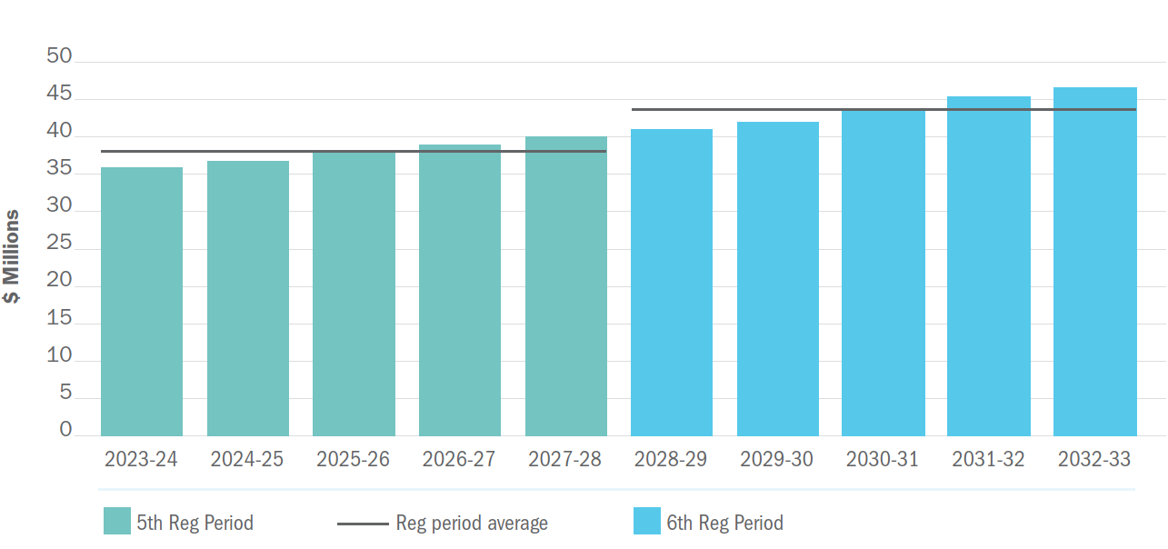

Key references relating to this chapter:
- Final ESC Model – DOC/22/51259

- Forecast operating expenditure
At a glance:
We will deliver service outcomes valued by customers at prices at 0.30% above CPI.
Our proposed operational cost efficiency improvement rate is CPI minus 0.75%, per annum (average).
Additional operational expenditure of $9.2M above the baseline has been identified and quantified in this submission.
Operational cost savings are aimed at keeping price increases as low as possible.

The operating costs included in this submission are both prudent and efficient considering the challenging environment East Gippsland Water is operating in. External factors outside our control are placing upwards pressure on input and employee costs with efficiencies becoming increasingly difficult to find. Extreme weather events have put immense pressure on our business in terms of emergency response as well as increasing our insurance premiums well beyond historic trends. There is a need to invest in more people, more training and increasing the resilience of our assets.
The challenge of attracting and retaining quality staff to this part of Victoria has meant employee costs are increasing at a rate greater than our approved Enterprise Agreement. Additional staff have been employed to meet the growing compliance requirements placed on water corporations, to maintain service standards to customers, and to help deliver our capital works program.
We reviewed our existing business strategies in the lead up to this Price Submission and new internal strategies were developed to profile the operational expenditure required for the 2023-28 regulatory period (refer to Chapter 3). The operational cost changes above or below the baseline year identified in these strategies were validated through multiple executive reviews.
  - Total and annual forecast operating expenditure
We forecast a total operating expenditure of $127 million in the five-year regulatory period. This includes $8 million in non-controllable expenditure such as regulatory licence fees and the environmental contribution.
Figures 4 and 5 outline the actual and forecast controllable operating expenditure over the current 2018-23 regulatory period, as well as a forecast for the next regulatory period. Each major service category has been segmented into the cost categories outlined in the guidance from the Essential Services Commission. The graphs show an increase in forecast expenditure from the 2021-22 baseline year to the 2023-28 period.
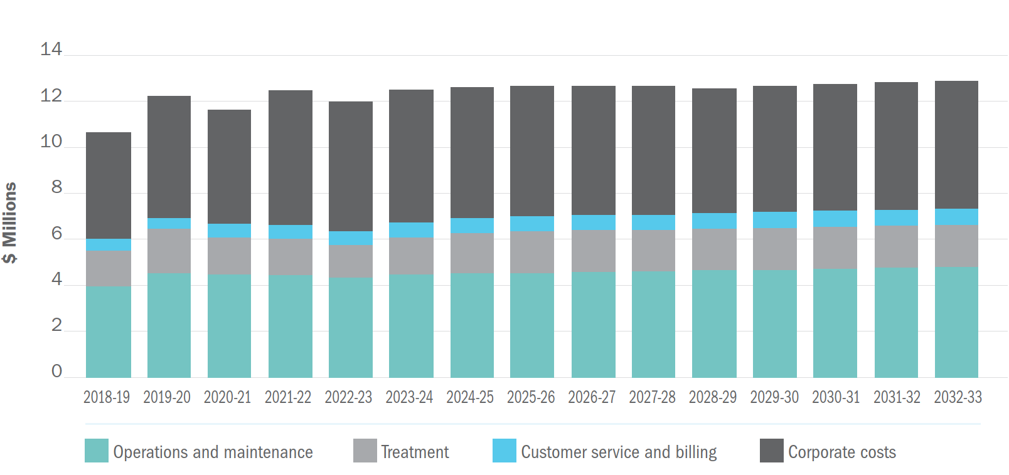
Figure 4: Controllable operating expenditure – Water (actual and forecast) for 2018-33¹

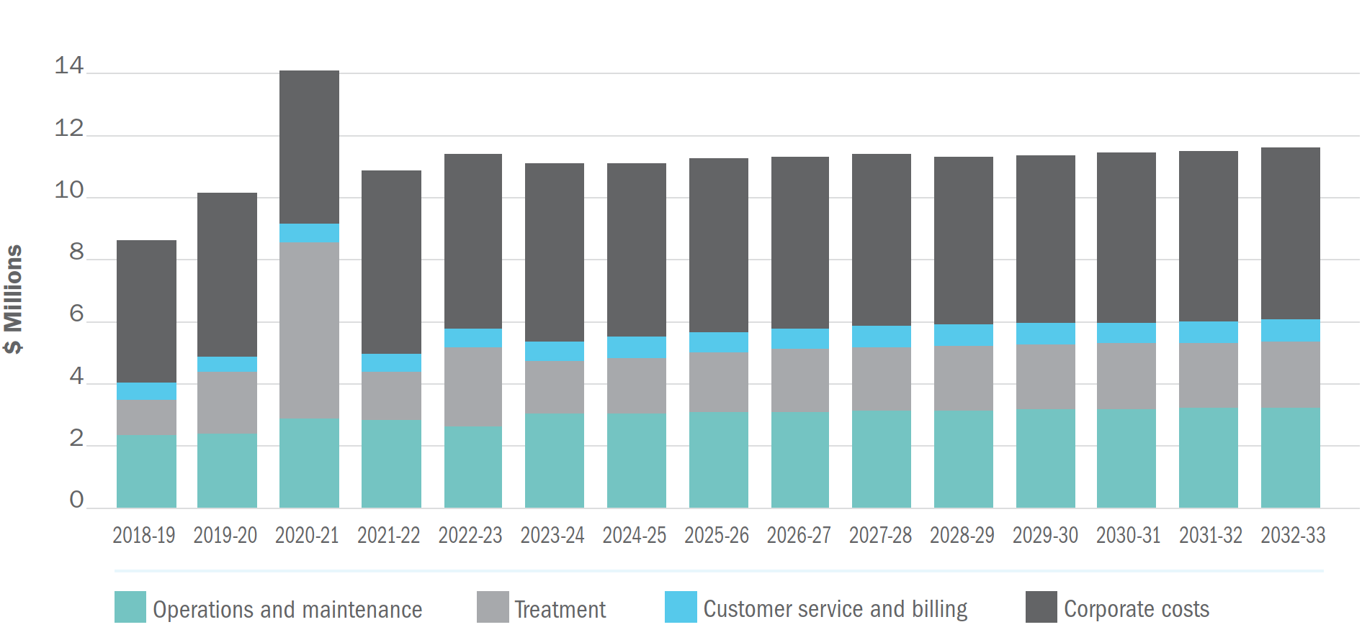Figure 5: Controllable operating expenditure – Sewerage (actual and forecast) for 2018-33¹
  - Baseline controllable operating expenditure
The 2021-22 financial year was used to develop a baseline controllable operating expenditure profile for the 2023-28 regulatory period. To do this, all non-controllable, one-off and non-recurring costs incurred in 2021-22 were removed from the baseline calculation.
The total prescribed operating expenditure for 2021-22 was $25.14million. However, once the non-controllable costs were removed along with the one-off and non-recurring costs, the baseline operating expenditure value is $21.71 million (refer to Table 27).
The resultant controllable expenditure for 2021-22 is $1.80 million, or nine per cent, higher than the 2021-22 controllable costs approved in the 2018-23 price decision (refer to Table 27). This reflects the challenges we faced over the 2018-23 period.
Table 27: 2023 regulatory period baseline operating expenditure summary¹
Baseline year – total prescribed operating expenditure in 2021/22 ($ million): |  | $25.14
Less non-controllable expenditure items incurred in 2021/22:
External bulk water charges (excluding temporary purchases) |  | $ 0.00
External temporary water purchases |  | $ 0.00
Licence fees |  | $ 0.07
Environmental contribution |  | $ 1.74
Other non-controllable |  | $ 0.00
Total |  | $1.81
Baseline year – total controllable operating expenditure in 2021/22 ($ million): |  | $23.34
Adjustments for non-recurring expenditure items incurred in 2021/22 and any efficiency savings to be realised from 2021/22:
Development of multiple Facility Master Plans |  | $ 0.37
Decommissioning of Kalimna tank |  | $ 0.14
Woodglen Partnerships Investigation |  | $ 0.03
Price Submission consultancy / preparation |  | $ 0.17
IT / Data strategy development & Gippsland Regional Water Syndicate work |  | $ 0.19
Change of accounting policy / asset threshold |  | $ 0.09
Customer engagement and reviews - PS2023-28 |  | $ 0.18
BWWTP and LEWWTP underground asset assessments |  | $ 0.20
Price Submission staffing – short-term contracts |  | $ 0.22
Class A review and 2021 adjustment for ZEW |  | $ 0.05
Total |  | $1.63
Baseline controllable operating expenditure 2022/23 ($ million) |  | $21.71
Comparison with approved 2021/22 total controllable opex per 2018 determination model
2021/22 | Difference | %
$19.91 | $1.80 | 9%

The $1.8 million (nine per cent) increase in controllable costs can be attributed to the following:
Chemical costs
Over the 2018-23 period, our chemical costs increased by ~$270,000 per year. There are three major reasons for the increase:
- Ageing infrastructure and plant capacity issues at the Bairnsdale Wastewater Treatment plant meant additional ferric sulphate dosing was required to meet compliance. This has increased operating costs at the plant by ~$130,000 per year.
- Water quality issues stemming from the 2019/20 Black Summer bushfires impacted our largest water treatment facility at Woodglen. The run off post the fires plus recent algae events has required additional treatment with chemicals adding ~$80,000 per year to the operating cost at this plant.
- New chemical supply contracts were negotiated in 2021 as part of a joint procurement process with other Gippsland based water corporations. Under the new contracts savings of $17,000 per year were estimated based on 2020 usage amounts. The impacts of COVID-19 and recent market conditions on supply chains, raw material and fuel cost has seen increases in chemical supply costs higher than CPI. This has increased costs for like for like chemicals by ~$40,000 per year.
Insurance costs
East Gippsland Water takes part in the water industry sourcing and procurement of insurance to provide the best buying power and insurance coverage possible. The current insurance broker for the industry is Marsh. The insurance market is currently in a ‘hard market cycle’ exacerbated by extreme rain events in Australia as well as insurable catastrophes overseas, and a potential ‘full limit loss’ within our sector. Overall, our insurance premiums have risen 47% over the 2018-23 period and our insurance costs have increased $70,000 per year.
Trainee opportunities
Over the past four years, we have proactively provided opportunities for local people in the form of traineeships across several disciplines. The aim of these traineeships is to provide an entry pathway into the workforce for local people with East Gippsland Water or outside the business post completion of their traineeship. This program has delivered us a number of high-quality staff and some have continued to progress through to senior roles within the business.
Over the four years there has been an increase of four traineeships offered, bringing the total number of traineeships currently in place to seven. This has increased costs by ~$200,000 per year and has been factored into our 2023-28 submission as part of our commitment to continue to support local jobs (Outcome 5).
Increased staff numbers and salary increments
The delivery of water and wastewater services to our customers is complex. There are many legislative requirements to be met across a broad range of areas, including water quality, health and safety, gender equality, and compliance with all aspects of organisational management. Due to an increase in our compliance and reporting requirements, particularly in relation to the Asset Management Accountability Framework, Public Construction Procurement and the Gender Equality Act, we have had to increase our staff to address the higher workload. As a leader in the community we have a responsibility to provide a psychologically safe workplace for our staff, by ensuring workloads are manageable and not leading to increased stress and mental / physical health issues.
In addition to these challenges, a series of major emergency related incidents (2019-20 Black Summer bushfires, COVID-19 pandemic and the 2021 and 2022 flood events) meant additional resources were also required across several functions within the business. This included:
- Emergency Management Co-ordinator
- Procurement Specialist
- Asset Management and Planning Specialists x 2
- Capital Delivery Program Managers and Works Inspector x 5
- SCADA Specialist
- People & Culture Coordinator
These positions are ongoing and included in our 2023-28 submission.

Current market conditions resulting from the COVID-19 pandemic and labour force shortages have placed pressure on us to ensure our salary packages are competitive so we can retain key staff and attract skilled workers to our business. Increases in the compulsory employer superannuation guarantee have further increased our staffing costs.
Overall, the above increases in staff numbers, salaries and compulsory employer superannuation guarantee equates to ~$1.2 million per year.
Controllable cost increase summary
The above details are the high-level headline cost increases experienced by East Gippsland Water over the 2018-23 period. There are a number of other minor incremental cost areas throughout the business which have increased operational expenditure.
We have attempted to minimise costs to the business and ultimately customers by proactively looking for and embedding costs efficiencies and/or savings where possible. Details are provided in the following section.
  - Operating expenditure savings
Efficiencies achieved during the 2018-23 period include²:
- Contracts for chemical supply, electricity supply and water/wastewater sampling and analytical services entered into with other Gippsland Regional Water businesses.
- New treatment plant waste collection contracts were tendered in 2020. The new contract estimated savings of approximately $1,600 per year however recent fuel cost increases have also seen the cost of waste collection increase.
- Implementation of various panel contracts covering plumbing supplies, grounds maintenance and eductor truck services.
- Behind the meter solar generation installed during the 2018-23 period has saved us approximately $55,000 in electricity costs. This is in addition to the solar installed prior to the period.
- Enhancements of our procurement framework ensuring robust practices are adhered to in basic operational expenditure purchases.
- Implementing the requirements of the Victorian Government Purchasing Board directives, ensuring value for money in procurement activities is considered and where possible, entering State based contracts to deliver the best cost outcomes.
An internal review and assessment of our business efficiency in comparison to other ‘medium’ sized water businesses, across a number of performance indicators, has been completed and shows we are operating efficiently and performing well for our size³.
For the 2023-28 regulatory period, we are committed to seeking further efficiency opportunities through the Gippsland Regional Water Alliance. We are also seeking to appoint a Process and Performance Improvement Specialist to identify and deliver operational savings.
Savings already embedded in the forecast include:
- A reduction over the period in consultancy cost for asset management improvement program saving $320,000⁴
- A reduction on overall electricity consumption through the implementation of energy efficiency projects saving $140,000⁵
- Changing the treatment of wastewater lagoon desludging to a project, smoothing the expenditure over several regulatory periods.
We have embedded an annual efficiency rate of 0.75% into this Price Submission. These efficiency opportunities will be sought in the following areas²:
Utilising current staffing as much as possible to absorb increased government compliance and social initiatives, while maintaining a safe workplace.
Continuing to work with the Gippsland Regional Water Syndicate to deliver an innovative billing solution across multiple businesses.
Implementing procurement and tendering process changes to provide economies of scale savings throughout our expenditure base (both capex and opex).
Treatment plant upgrades and optimisation to reduce chemical usage.
Investing in plant and equipment for network maintenance and reducing reliance on contractors.
  - Operating expenditure increases
The following operating cost increases above the baseline have been allowed for in this Price Submission:
Migration of Technology One software from “on-premise” to hosted Software as a Service as required by provider by 1 October 2023. $880,000 over the 2023-28 Price Submission period has been included.⁶
IT cyber security enhancements as outlined in current IT Strategy completed in 2021. Establishment of a Security Operations Centre and resource changes to ensure cyber security of our data is at a level minimising risk to customers and the business. Investment of $1.79 million required over the 2023-28 Price Submission period.⁷
Overhaul the IT Foundation Architecture – investment of $1.06 million required.⁷
Increased electricity costs in line with government initiatives for green power and aligned with Vic Water project – total cost $1.2 million.⁸
Additional five staff members across operations, performance, trade waste and energy efficiency to meet our service standards and compliance obligations. Our ambitious energy reduction program requires dedicated resources to achieve, while the review of major trade waste tariff structure has indicated internal resources are required before any advancement in tariff review can occur. Total cost increase of $2.38 million.⁹
Additional opex stemming from new capital works infrastructure – total cost of $580,000.¹⁰
Increase in hardship measures in place for customers experiencing payment difficulties – recommendation from the customer Deliberative Forum – total cost of $500,000.¹⁰
Salary increments awarded at the end of the 2021/22 baseline year have been included in our submission. This reflects changes in employee remuneration to retain current high performing staff and also sets new benchmarks for attracting new employees. A total of $1.1 million has been included.
Including the savings in asset management consultancy costs outlined in section 8.3, this Price Submission includes an additional $9.2 million in operational expenditure to deliver the initiatives outlined above.
  - Annual cost efficiency improvement rate
Taking into consideration the above narrative, we plan to deliver an average controllable cost efficiency improvement for the Price Submission period of CPI minus 0.75% per annum. The forecast cost efficiency improvement rate for each year of the 2023-28 regulatory period is shown in Table 28.
Table 28: Cost efficiency improvement rates for the 2023-28 period
 | 2023/24 | 2024/25 | 2025/26 | 2026/27 | 2027/28
Cost efficiency improvement rate (%per annum) | 0.75% | 0.75% | 0.75% | 0.75% | 0.75%

  - Allocation of corporate costs
Most of the corporate costs (90%) are recorded against our head office facility. When using the financial model provided by the Essential Services Commission, the basis for allocation of corporate costs is a 50:50 split between water and sewerage services.
Key references relating to this chapter:
- Final ESC model – DOC/22/51259
- Business Efficiency Strategy – DOC/20/47750
- Business efficiency assessment report – DOC/22/38065
- Asset Management Strategy – DOC/21/40740
- Climate Change Strategy 2023-2028 – DOC/22/12403
- End of Premise Letter of Offer from Technology One – DOC/22/39905
- IT Strategy and work packages – DOC/21/56907 and DOC/21/50521
- Intelligent Water Networks (IWN) Electricity Price Forecast – Covering FY2023-2028 – DOC/22/19874
- Memorandum – PS2023 Price Submission above BAU opex and planning and investigations program - DOC/22/22029
- Opex from new capex summaries – DOC/22/14455 and DOC/22/41224

- Forecast capital expenditure
At a glance:
$115 million capital works program over five years to secure drinking water supplies, protect the environment, and respond to population growth and climate change.
$26 million to construct a third raw water storage at Woodglen and significant investment in major improvements at our Bairnsdale ($14 million) and Paynesville ($11 million) wastewater treatment facilities.
66% spend on top 10 projects.
23% spend on capital programs (ongoing through regulatory period).
11% spend on ‘other projects’, such as those for compliance and growth, which are not considered capital programs or top 10.
  - Summary of capital expenditure program
We plan to invest $115 million in capital works over the regulatory period. This figure takes into account portfolio risk management, regulatory compliance requirements, climate change, customer feedback, levels of service, projections for population growth, asset condition/performance, health, safety and environmental obligations. The planned expenditure does not include allocations for third-party funded works, such as developer works.
The proposed capital expenditure of $115 million is an 74% increase to the projected capital expenditure of $66 million during 2018-23. The increase is due to a significant investment to secure drinking water supplies and to upgrade wastewater treatment plants in response to population growth and a changing climate; an increased focus on renewing ageing assets to meet our regulatory compliance obligations, and improving environmental outcomes (refer to ‘top 10’ tables in Section 9.3).
This increased investment cannot be delayed any further. In the last few years we have experienced the driest period on record with climate science predicting that these trends will worsen. We risk severe and prolonged water restrictions if these upgrades are not implemented before the next drought. At the other end of the scale, we are now experiencing one of the wettest periods on record, requiring us to undertake controlled emergency discharges from a number of our wastewater treatment plants attracting scrutiny from the EPA.
Further to investing in our response to climate change, we are also committed to playing our part in addressing climate change impacts. In 2021/22 we committed to reducing our greenhouse gas emissions to net zero by 2035, as our local contribution to addressing the impacts of long-term climate change. This requires significant capital expenditure in renewable energy generation.
Figure 6 shows the historical and projected future increase in capital expenditure transferred to the RAB by service category.
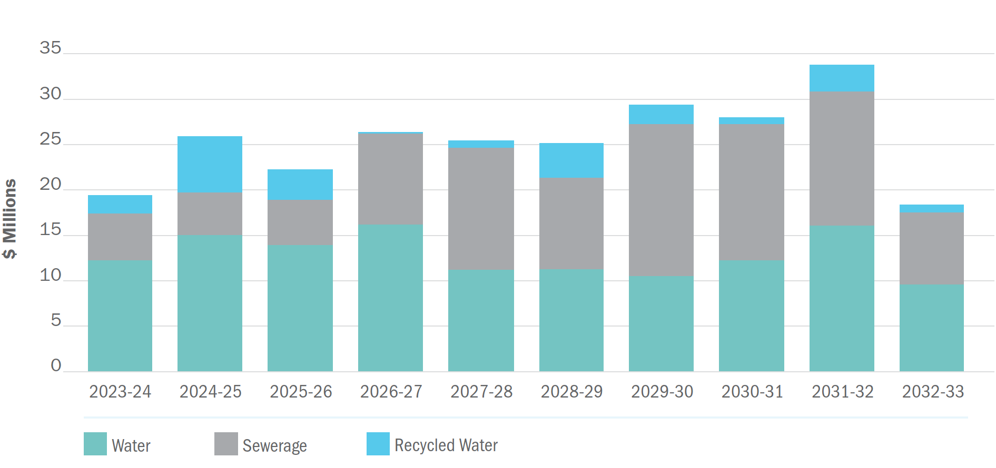
Figure 6: Historical (actual) & forecast capital expenditure transferred to the RAB by service category
As shown in Figure 7, projects with renewals as their driver form the main component of our capital program, accounting for 43% of the overall forecast.
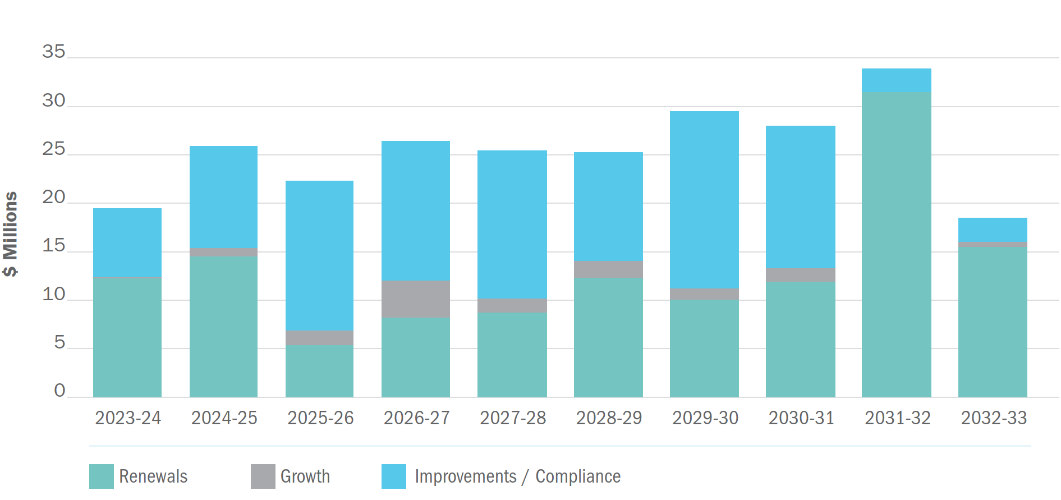
Figure 7: Total capital expenditure each year 2023-2033 by driver

  - Major capital projects
An overview of each of our top 10 projects by cost is outlined in the tables below, including their drivers, links to outcomes, estimated cost, timing and background. The total capital expenditure for the top 10 major projects represents 66% of the planned capital expenditure over the five-year regulatory period.
Table 29: Project 1: Woodglen third raw water storage (around 800ML)¹
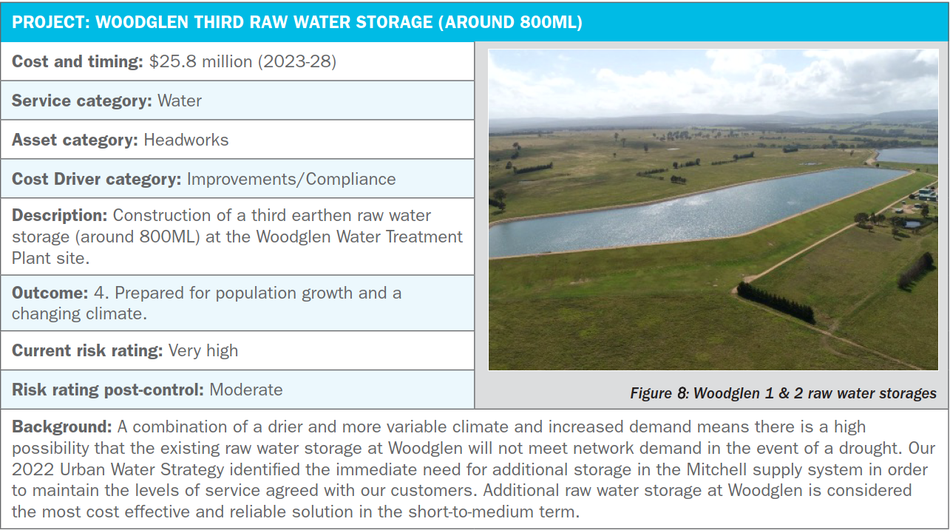

Table 30: Project 2: Paynesville additional recycled water storage (around 300ML) and pump station²
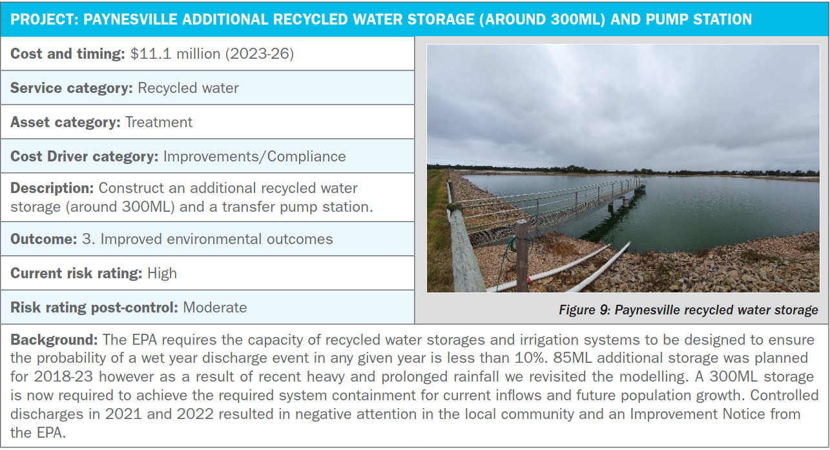
Table 31: Project 3: Bairnsdale wastewater treatment plant stage 1 major upgrades³
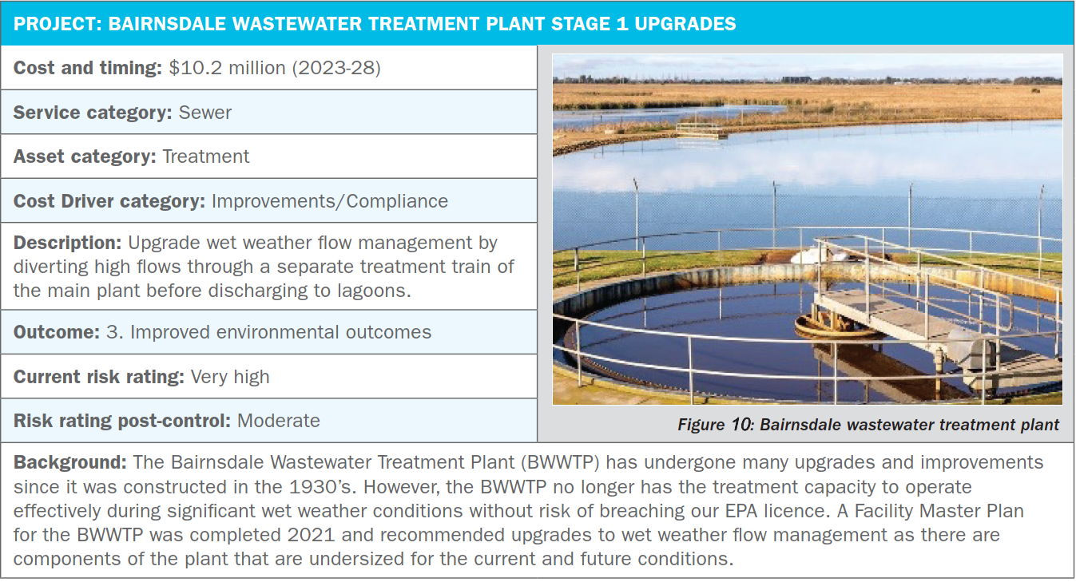

Table 32: Project 4: Woodglen to Wy Yung main supply pipeline upgrade (2.8km of DN750)⁴
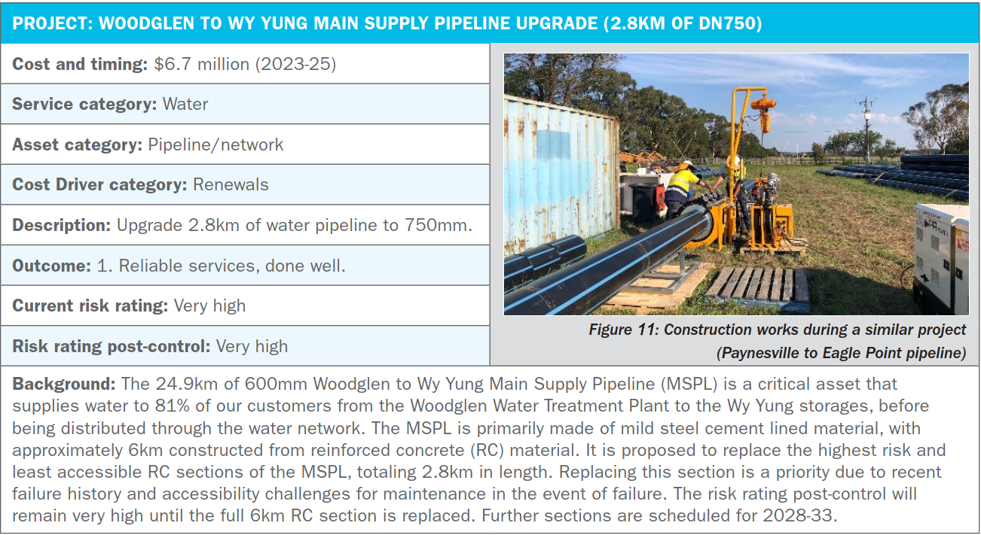
Table 33: Project 5: Replace liner and cover of Wy Yung No. 1 clear water storage⁵
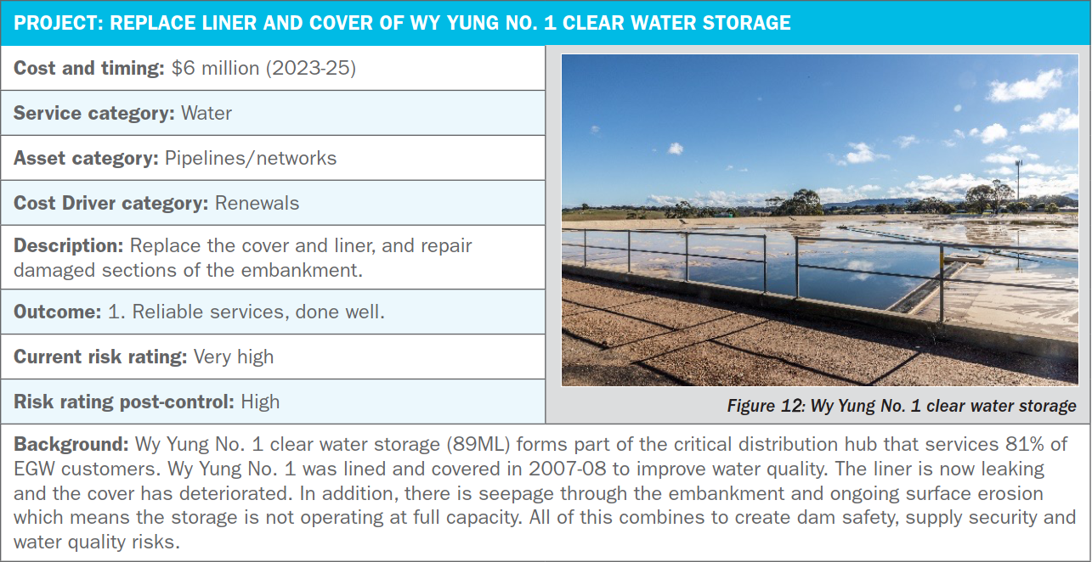

Table 34: Project 6: Bairnsdale wastewater treatment plant stage 2 major upgrades⁶
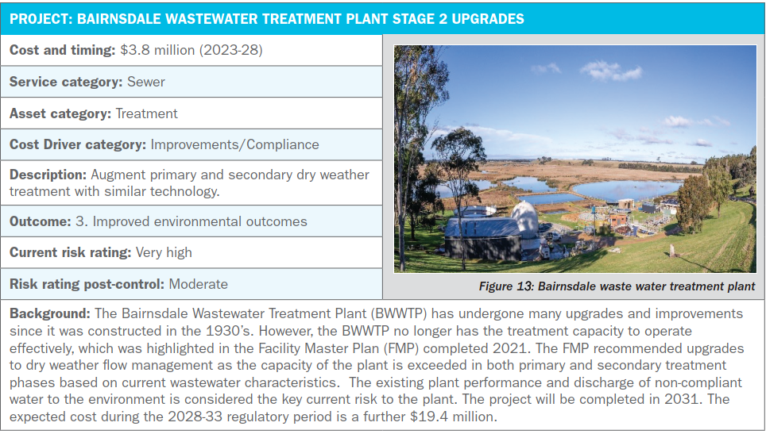
Table 35: Project 7: Replace Buchan clear water storage tanks (around 1ML)⁷
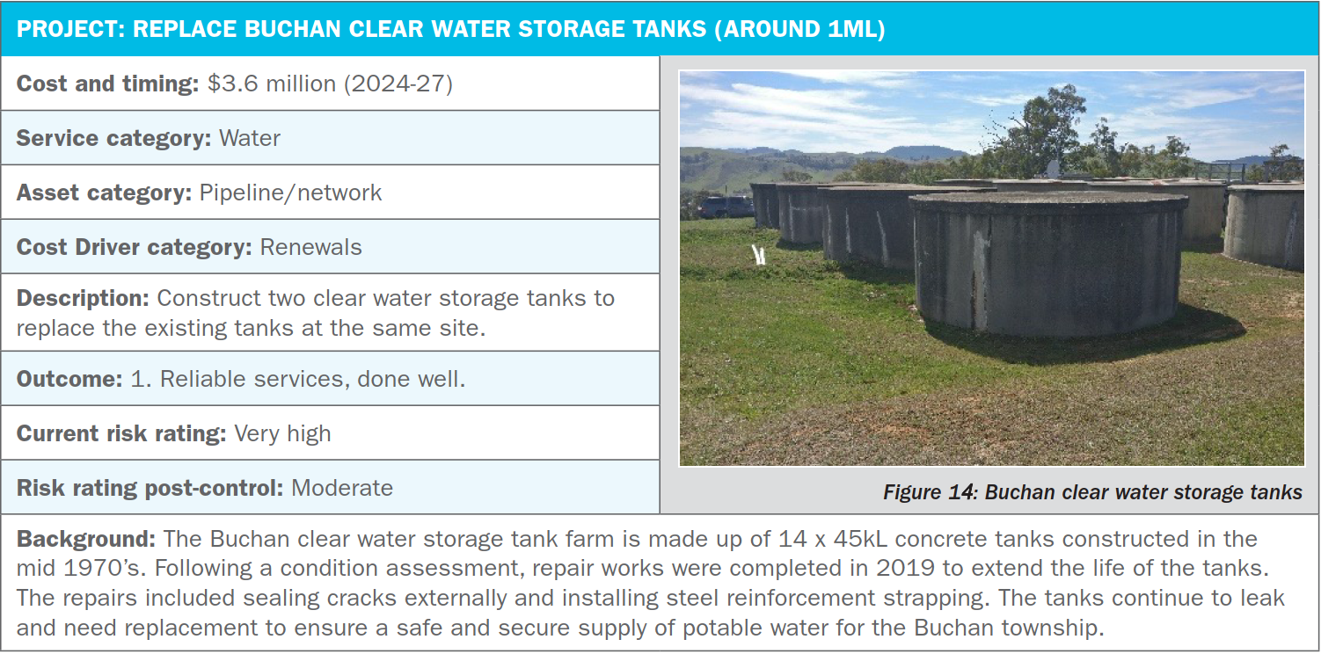

Table 36: Project 8: New 1ML clear water storage tank and pump station at Marlo⁸
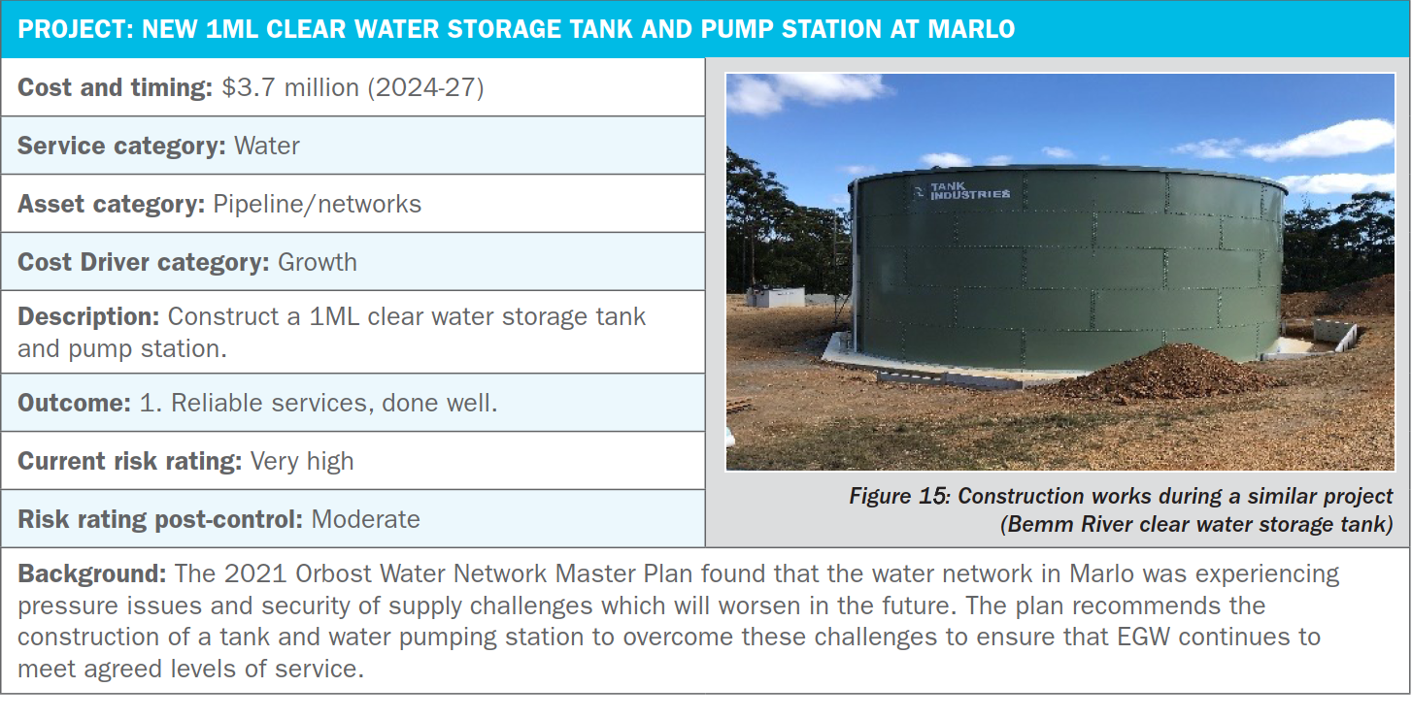
Table 37: Project 9: Lakes Entrance North Arm bridge water main replacement (400m of DN450)⁹
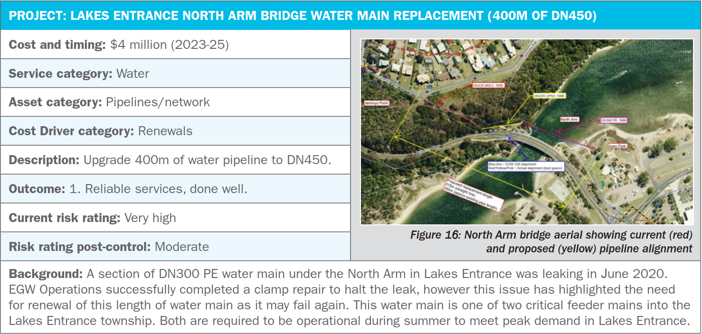

Table 38: Project 10: Bairnsdale sewer network – Day Street upgrades¹⁰
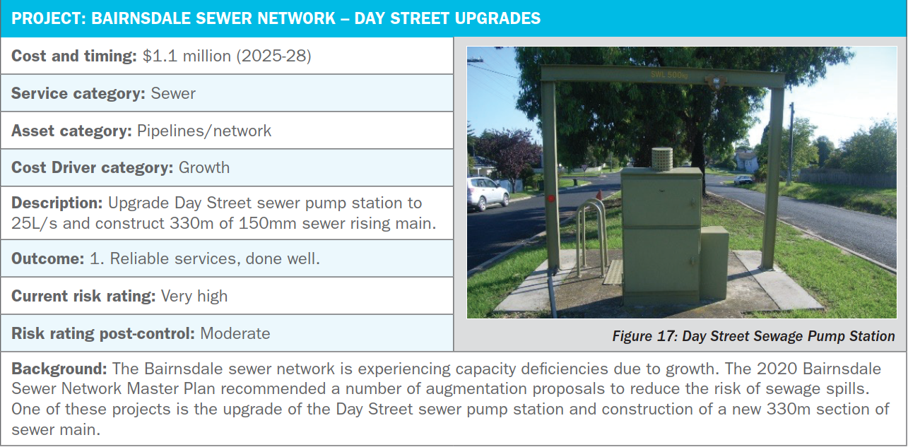
  - Capital programs and other capital expenditure
Apart from the ‘top 10’ projects, our capital investment is grouped into either ‘programs’ that are ongoing throughout the 2023-28 period, or as ‘other capital expenditure’, which is discrete projects driven by compliance or growth objectives, and not considered top 10 projects or capital programs. The ‘capital programs’ account for approximately 23% of the proposed capital investment over the five-year regulatory period, and ‘other capital expenditure’ accounts for approximately 11% of the proposed expenditure from 2023-28. These two groups are shown in Table 39.
Table 39: Details of capital ‘programs’ and ‘other projects’ (not including top 10)
PROGRAMS | RELATED OUTCOME(S) | OBJECTIVES | COMPARISON TO PS2018 COSTS¹¹ | FIVE-YEAR TOTAL ($M)
IT systems¹² | 1. Reliable services, done well | To ensure IT infrastructure supports efficient planning and operational activities. Replace legacy systems no longer supported and replace obsolete hardware. Reduce cyber security risks. | Decrease from PS2018 costs. | $1.73
Energy efficiency¹³ | 1. Reliable services, done well  3. Improved environmental outcomes | To reduce energy consumption and meet our emissions reduction pledge. | Decrease from PS2018 costs. | $0.80
Plant and equipment¹⁴ | 1. Reliable services, done well | To ensure plant and equipment is sufficient to provide efficient field based and office activities. | Significant increase from PS2018 costs. | $3.79
Motor vehicles¹⁵ | 1. Reliable services, done well | To ensure a safe, fit-for-purpose and cost-efficient vehicle fleet. | Significant increase from PS2018 costs. | $2.61
Renewals – sewer¹⁶ | 1. Reliable services, done well | To maintain asset base in working order. To ensure an appropriate balance between maximising asset lifespan and the risk of asset failure. | Modest decrease from PS2018 costs. | $9.73
Renewals – water¹⁶ | 1. Reliable services, done well |  | Small decrease from PS2018 costs. | $6.29
SCADA upgrades¹⁷ | 1. Reliable services, done well | To ensure reliable water and sewer system monitoring and control | Significant increase in expenditure from PS2018 costs. | $1.43
Other capital expenditure - sewer | 1. Reliable services, done well  3. Improved environmental outcomes  4. Prepared for population growth and a changing climate | To invest in upgrades to improve compliance, operational efficiency and ability to meet current levels of service into the future. | Significant increase in other projects in response to population growth and climate change; meeting our regulatory compliance obligations, and improving environmental outcomes. | $5.06
Other capital expenditure -water |  |  |  | $7.81
Total |  |  |  | $39.24

  - Method for developing the capital expenditure program
The following aspects were relevant to the development of the capital program:
- Strategies and Master Plans
Internal business strategies and master plans were reviewed/developed to profile the capital expenditure required for the 2023-28 regulatory period (refer to Chapter 3).
Renewals¹⁶
The methodology for the renewals program involves developing renewals models, condition inspections, renewals forecasting and a prioritisation process.
The renewals models identify which assets should be considered for condition assessments (prior to renewal) to ensure our decision-making is based on evidence rather than purely a desk-top review.
The renewals forecasting builds on the renewal’s models, using information such as asset age, condition, expected asset life and criticality, as well as benchmarked asset replacement costs to identify the assets that need to be replaced in the 5-year and 20-year period.
These forecast renewals were then bundled into projects based on asset type and location, and then verified with the facility owners/subject matter experts for inclusion into the 2023-28 price period.
The renewals models are used on an annual basis to review and prioritise asset renewals as new data becomes available, whereas the renewals forecasting is used to develop the forecast for the longer-term renewals planning.
Risk-based project prioritisation¹⁸
All discrete projects were ranked in order of priority having regard to our risk appetite using the following inputs:
  - The inherent risk of the issue to East Gippsland Water (before controls).
  - The reduction in risk resulting from investment in the control.
  - The cost of the control.
Further information relating to the project prioritisation process can be provided upon request.
P50 estimates
All ‘top ten’ projects had P50 estimates completed to ensure a robust forecast was achieved for prudent and efficient expenditure¹⁻¹⁰.
Given current market conditions, volatility and uncertainty of cost estimates, particularly with regard to the construction of storages, we have opted to adopt the base case costs estimates rather than the P50 estimates for the third water storage at Woodglen and Paynesville waste water treatment winter storage). We believe this to be a reasonable approach that avoids passing on this high level of uncertainty to customers (refer to Chapter 4).

Program development
From the ranked list of prioritised and justified projects, a 20-year program was developed using an iterative process of:
  - Optimisation of the 20-year program to ensure balanced expenditure over regulatory periods.
  - Providing a number of risk-based scenarios and the price impacts for consideration by the Board.
  - Deferring projects or only including planning costs where scope, timing and cost are uncertain.
  - Staging and timing projects for delivery.
  - Bringing forward $5 million of design costs for projects in response to deliberative forum recommendations.
  - Cost efficiencies
The infrastructure investment budget proposed in this price submission incorporates many cost efficiencies developed through delivery of infrastructure programs in previous regulatory periods. Some examples include:
- Delivering the renewals programs as groups of like projects – this has proved to significantly reduce the cost of the renewals program through economies of scale and reduced project management and approval costs¹⁶.
- Setting up multi-year panel contracts to improve procurement efficiency and deliverability.
- Ensuring planned renewals result in an operational saving.
- Assessing the condition of water and sewerage assets scheduled for renewal using techniques such as CCTV, pressure transients, and acoustic techniques to determine the need and timing for renewal. This process ensures assets are replaced due to condition, rather than theoretical life span. In many cases assets remain in service beyond their theoretical life while still meeting customer service levels or regulatory requirements¹⁶.
- Taking a risk-based approach to determine the need for asset upgrades¹⁶.
- A strong focus on reducing infiltration and inflow to minimise the volume of wastewater requiring treatment and management¹⁶.
- Projects to deliver energy use efficiencies have been justified and prioritised based on financial return. By focusing on reducing electricity usage through efficiency and behind-the-meter renewables rather than offsets, we are reducing our dependence on the retail market and future price fluctuations¹³.
- Over the course of the current regulatory period, we have worked steadily to continue to grow and develop our in-house capability in our asset planning and capital delivery teams. We have done this because it is important to get the balance right between inhouse and external capability to achieve the best value outcomes for our customers.
  - Capacity to deliver
Our past performance shows we have delivered a larger program in 2018-2023 compared to 2013-2018 in the face of significant challenges. Our projected total expenditure in the current regulatory period to June 2023 is expected to be within about 5% of the overall five-year budget of $62 million (present value).
We have a strong base to build on and have already implemented a number of changes to support the delivery of a larger program, being:
- Implementation of improved procurement strategies via the use of multi-year renewals programs.
- Tendering like projects together to be more attractive to potential bidders and gain efficiency savings.
- Access to significant engineering design, project management and superintendent resources through our established external engineering services contracts with GHD, CMP and Crossco. This gives us more flexibility and ability to run more projects concurrently and leverage secondment opportunities to balance resourcing against peaks and troughs. This is in comparison to the previous period when we had a single engineering services provider.
- A number of major projects are already well advanced in the design stage.
- Phasing of project stages and expenditure with deliverability in mind.
- An increase in our in-house project management team from four (in 2018) to nine (in 2022) with capacity to add additional resources if required.
Delivery of the projected $115 million capital budget over five years may require further enhancements to our delivery capability. We have already initiated an independent expert review to ensure we have the capability and capacity to deliver these essential works¹⁹.
Key references relating to this chapter:
- Third water storage at Woodglen P50 cost estimate – DOC/22/42991
- Bairnsdale WWTP major upgrades stage 1 P50 cost estimate – DOC/22/42973
- Paynesville WWTP additional winter storage and pump station P50 cost estimate – DOC/22/42986
- Woodglen to Wy Yung MSPL upgrade P50 cost estimate – DOC/22/42992
- Replace liner and cover of Wy Yung No.1 clear water storage P50 cost estimate – DOC/22/42993
- Bairnsdale WWTP major upgrades stage 2 P50 cost estimate – DOC/22/42975
- Replace Buchan clear water storage tanks P50 cost estimate – DOC/22/42979
- New clear water storage tank and pump station at Marlo P50 cost estimate – DOC/22/42983
- Lakes Entrance North Arm bridge water main replacement P50 cost estimate – DOC/22/42984
- Bairnsdale sewer network Day Street upgrades P50 cost estimate – DOC/22/42977
- Capex program comparison – DOC/22/32764
- ICT Strategy – DOC/21/56908
- Climate Change Strategy – DOC/22/12403
- Service Delivery Strategy – DOC/22/25685
- Fleet Management Strategy – DOC/22/12310
- Asset Management Strategy – DOC/21/40740
- SCADA Strategy – DOC/22/36102
- PS2023 Capital Projects Prioritisation Consolidated Results – DOC/22/32260
- Proposal for Capability Assessment Delivery of the Future Capital Works Program – DOC/22/52542

- Return on the regulatory asset base
At a glance:
Opening RAB at 1 July 2023 expected to be $182.4 million.
Overall PREMO rating of standard = 4.1% return on equity.
  - Forecast regulatory asset base
Based on the actual expenditure for 2021/22, the closing value for our regulatory asset base (RAB) was $176.81 million.
By incorporating the estimated expenditure for 2022/23 provided by the Essential Services Commission, we expect an opening RAB as at 1 July 2023 of $182.4 million.
The proposed capital expenditure program for the 2023-28 regulatory period is forecast to increase our RAB in line with Table 40:
Table 40: Forecast value of the RAB for the 2023-28 period
$ million | 2023/24 | 2024/25 | 2025/26 | 2026/27 | 2027/28
Opening asset base | 182.41 | 195.72 | 214.85 | 229.69 | 247.74
plus capital expenditure | 19.57 | 26.05 | 22.38 | 26.55 | 25.64
less disposals | 0.39 | 0.34 | 0.16 | 0.44 | 0.29
less regulatory depreciation | 5.87 | 6.59 | 7.37 | 8.06 | 8.91
Rolled forward RAB | 195.72 | 214.85 | 229.69 | 247.74 | 264.19

The composition of the RAB over the 2023-28 regulatory period is represented in Figure 18, which shows the impact of the proposed capital investment program on the RAB.
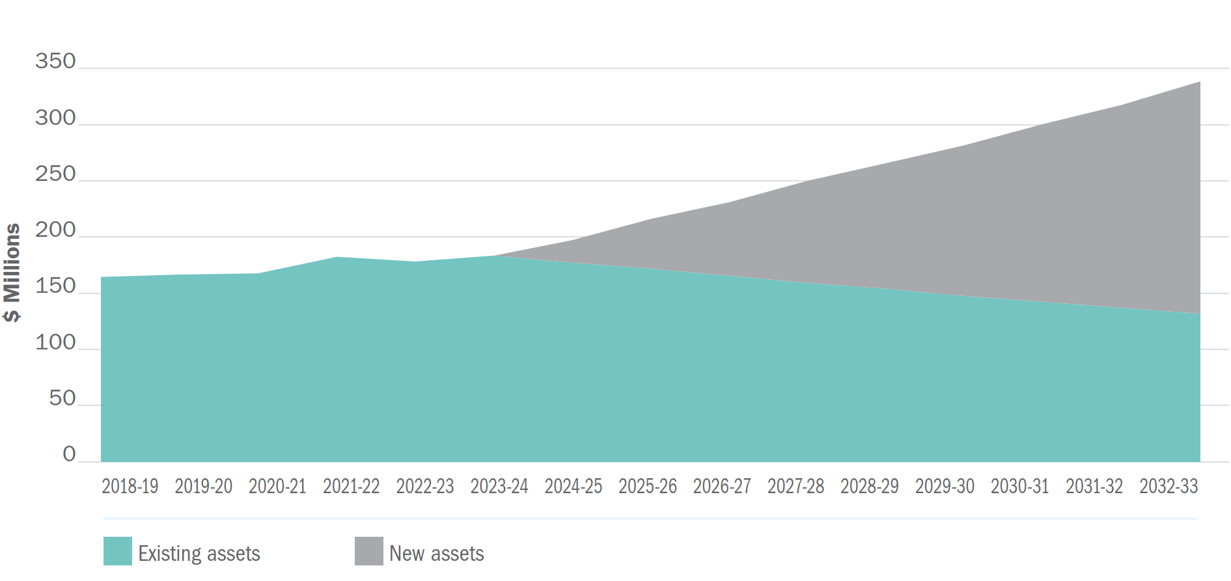
Figure 18: Composition of the RAB 2018-28

  - Forecast RAB until 2032/33
We forecast expenditure on capital works to increase in the sixth regulatory period, from $115 million in the 2023-28 period, to $131 million for 2028-33, excluding the desludging allowance. This will increase the value of the RAB by the end of 2028/33 as shown in Table 41.
Table 41: Forecast RAB each year 2023-33¹
 | fifth reg period |  |  |  |  | sixth reg period
$ million | 2023/24 | 2024/25 | 2025/26 | 2026/27 | 2027/28 | 2028/29 | 2029/30 | 2030/31 | 2031/32 | 2032/33
Opening asset base | 182.41 | 195.72 | 214.85 | 229.69 | 247.74 | 264.19 | 279.52 | 298.53 | 315.06 | 336.35
plus capital expenditure | 19.57 | 26.05 | 22.38 | 26.55 | 25.64 | 25.34 | 29.62 | 28.12 | 34.06 | 18.50
less disposals | 0.39 | 0.34 | 0.16 | 0.44 | 0.29 | 0.31 | 0.31 | 0.31 | 0.31 | 0.31
less regulatory depreciation | 5.87 | 6.59 | 7.37 | 8.06 | 8.91 | 9.71 | 10.29 | 11.29 | 12.46 | 13.26
Rolled forward RAB | 195.72 | 214.85 | 229.69 | 247.74 | 264.19 | 279.52 | 298.53 | 315.06 | 336.35 | 341.29
  - Regulatory depreciation
Table 42 outlines the forecast regulatory depreciation profile for the period in addition to depreciation on existing assets. All depreciation is calculated on a straight-line basis.
Table 42: Estimated regulatory depreciation 2023-28¹
$ million
 |  |  |  |  | Fifth Reg Period
asset class | remaining life | book value | % of total | average asset life | 2023/24 | 2024/25 | 2025/26 | 2026/27 | 2027/28
Buildings | 54 | 1.35 | 0.7% | 0.40 | 0.03 | 0.03 | 0.03 | 0.03 | 0.03
Intangibles | 9 | 1.09 | 0.6% | 0.05 | 0.12 | 0.12 | 0.12 | 0.12 | 0.12
Motor vehicles | 6 | 1.41 | 0.8% | 0.05 | 0.24 | 0.24 | 0.24 | 0.24 | 0.24
Office equipment | 5 | 0.65 | 0.4% | 0.02 | 0.13 | 0.13 | 0.13 | 0.13 | 0.13
Plant & equipment | 6 | 0.74 | 0.4% | 0.02 | 0.12 | 0.12 | 0.12 | 0.12 | 0.12
Water infrastructure | 34 | 104.96 | 57.5% | 19.56 | 3.09 | 3.09 | 3.09 | 3.09 | 3.09
Wastewater infrastructure | 38 | 72.21 | 39.6% | 15.04 | 1.90 | 1.90 | 1.90 | 1.90 | 1.90
Total – existing assets |  |  |  |  | 5.62 | 5.62 | 5.62 | 5.62 | 5.62

  - Government contributions
The capital works program included in this price submission does not include any provision for government contributions.
  - Gifted/donated assets
We receive gifted/donated assets from developers and the value of these assets varies considerably year on year. A conservative amount of $1.5 million per year has been included in this submission, directly impacting our tax recovery allowance. Taking a conservative approach, ensures customers are not contributing to tax allowance unnecessarily.
  - Customer contributions
We are part of the VicWater led review of NCC involving eight water corporations. A uniform model, based on the average incremental cost methodology has been developed and we are currently populating this model based on known inputs. However, we are not in a position to progress this methodology to point where we are confident it meets the requirements of this submission and consequently we will retain $0 new customer contributions for the 2023-28 pricing period, whilst maintaining the ability to negotiate new customer contributions as required.
  - Cost of debt
The 10-year trailing average approach provided by the Essential Services Commission has been used to estimate the benchmark cost of debt in the pricing model (including the historic cost of debt values outlined in the 2023 Water Price Review Guidance).
  - PREMO rating and the regulated return on equity
Using the PREMO assessment tool provided in the 2023 Water Price Review Guidance, we have assessed our PREMO rating as Standard. Detail of our assessment is provided in Table 2 on page 3 and Chapters 2 to 6. The return on equity applied in the pricing model is 4.1%.
Key references relating to this chapter:
- Final ESC model – DOC/22/51259

- Tax allowance
At a glance:
We are in a tax paying position under the National Tax Equivalent Regime.
A company tax rate of 25% has been used for each year of the regulatory period.

We are in a tax paying position under the National Tax Equivalent Regime.
  - Price submission tax rates
Based on current taxation legislation (Enterprise Tax Plan No. 2 2017), a company tax rate of 25% has been used for each year of the 2023-28 regulatory period. Should our revenue base exceed $50 million, then a tax rate of 30% is applicable. This is not forecasted for the PS2023-28 period.
  - Income tax estimate
Table 43 contains the estimated income tax payable for the next two regulatory periods, based on the pricing model outputs:
Table 43: Income tax payable 2023-33¹
 | fifth reg period |  |  |  |  | sixth reg period
$ million | 2023/24 | 2024/25 | 2025/26 | 2026/27 | 2027/28 | 2028/29 | 2029/30 | 2030/31 | 2031/32 | 2032/33
Tax liability | 0.04 | 0.10 | 0.17 | 0.22 | 0.29 | 0.32 | 0.32 | 0.39 | 0.45 | 0.49

Key references relating to this chapter:
- Final ESC model – DOC/22/51259

- Demand
At a glance:
- Demand forecasts per connection remain similar to the previous period and factor in the demand experienced in the recent extreme dry and wet periods.
- Forecast residential customer growth projections were based on Victoria in Future 2021, East Gippsland Shire Council projections and our historic customer connections data.
- Non-residential growth was forecast based on trends from our own connection history data.
- Residential and non-residential customer usage was forecast from our own water usage data.
- We will continue to promote water education programs that encourage efficient water use.
  - Method
The method for forecasting water demand for the 2023-28 regulatory period involved reviewing and choosing an appropriate growth rate for both residential and non-residential customers from the various sources available.
Residential growth rates are based on Victoria in Future 2021 projections for our region as well as East Gippsland Shire Council projections (.ID) and our own historic customer connection data. Importantly, these forecasts consider the effects of the COVID-19 pandemic on growth in East Gippsland.
For non-residential connections, growth rates were based on the average of the last five years growth data (2017-18 to 2021-22).
Residential and non-residential water usage was calculated using the average of the last three years of water usage data (2019-20 to 2021-22).
  - Growth rates
Table 44 summarises the adopted growth rates for this price submission compared with the 2018-23 regulatory period.
We have assumed growth rates between 1.45% and 1.48% for residential customers and a growth rate of 0.23% for non-residential customers.
Table 44: Actual and forecast compound annual growth rates¹
 | fourth reg period |  |  |  |  | price submission
 | 2018/19 | 2019/20 | 20250/21 | 2021/22 | 2022/23 | 2023/24 | 2024/25 | 2025/26 | 2026/27 | 2027/28
Residential connections | 1.7% | 1.4% | 2.0% | 1.9% | 1.48% | 1.48% | 1.48% | 1.48% | 1.45% | 1.45%
Non-residential connections | 0.4% | 0.4% | -0.6% | 0.1% | 0.23% | 0.23% | 0.23% | 0.23% | 0.23% | 0.23%
Total connections | 24,128 | 24,448 | 24,859 | 25,272 | 25,651 | 26,031 | 26,416 | 26,807 | 27,193 | 27,585

  - Demand calculations
The adopted growth rates were used to forecast the total water demand (see Table 45).
We have assumed 141 kilolitres per annum average usage for residential customers and 517 kilolitres per annum average usage for non-residential customers.
Table 45: Actual and projected water demand¹
 | fourth reg period |  |  |  |  | price submission
 | 2018/19 | 2019/20 | 20250/21 | 2021/22 | 2022/23 | 2023/24 | 2024/25 | 2025/26 | 2026/27 | 2027/28
Kilolitres per connection
Residential | 160 | 153 | 145 | 126 | 141 | 141 | 141 | 141 | 141 | 141
Non- residential | 579 | 538 | 515 | 497 | 517 | 517 | 517 | 517 | 517 | 517
consumption megalitres
Residential | 3,386 | 3,286 | 3,177 | 2,818 | 3,203 | 3,250 | 3,299 | 3,347 | 3,396 | 3,445
Non- residential | 1,707 | 1,592 | 1,515 | 1,466 | 1,527 | 1,530 | 1,534 | 1,537 | 1,541 | 1,544
Total consumption megalitres | 5,093 | 4,878 | 4,692 | 4,284 | 4,730 | 4,780 | 4,833 | 4,884 | 4,937 | 4,989

The demand projections detailed above are based on the following assumptions:
- No additional new district/town water services are planned.
- No significant changes in water demand from major non-residential customers.
- No climate change impacts beyond what is built into the baseline year.
- Continuation of permanent water saving rules.
- No water restrictions are triggered during the regulatory period.
- No implementation of recycled water initiatives to offset potable water demand.
  - Price elasticity of demand
This submission proposes an increase in bill of CPI + 0.30%. Price elasticity has not been considered in our demand forecasts as most of an average residential customer combined bill comprises fixed charges. The tariff mix of approximately 40% service charge and 60% usage charge for the average residential customer water bill will remain unchanged for the regulatory period.
  - Demand management
Consistent with the Victorian Government’s Water for Victoria policy, the recently released Central and Gippsland Sustainable Water Strategy, and our 2022 Urban Water Strategy², we are committed to educating customers about water use in a bid to highlight the value of water, and influence efficient water use and water demand. The commitment is reflected in our customer outcomes, measures and new guaranteed service level relating to the introduction of a water efficiency rebates program.
Where feasible, we will continue to pursue small and large-scale uses of recycled water, or other water sources to offset drinking water demand.
While demand management wins have not been included in our demand forecasts, we expect that they will help offset growth in the region and delay subsequent major water supply/storage investments in the region.
  - Incorporating demand into operational budgets
Operating expenditure forecasts have been adjusted to allow for these demand projections (for example marginal costs of increased electricity and chemical usage have been included).
Key references relating to this chapter:
- EGW Growth Projections Master - DOC/16/2886[v3]
- 2022 Urban Water Strategy - DOC/22/5483

- Form of price control
At a glance:
Retaining ‘individual price cap’ form of price control, with the exception being a ‘tariff basket’ price control for major trade waste tariffs.
Customers will have greater price certainty.
Prices will be easier to administer and explain.

We propose to continue with ‘individual price cap’ form of price control in the 2023-28 regulatory period as per the 2018-23 period. The exception being our proposal to introduce a ‘tariff basket’ form of price control for major trade waste tariffs.
An individual price cap form of control provides customers with greater price certainty and is easier to administer and explain. This control provides customers with a set price for agreed levels of service and will avoid price adjustments.
Should water usage and growth significant exceed what has been forecast during the regulatory period, resulting in higher than forecast revenue in a particular year, we have the discretion to set lower prices than the maximum approved in subsequent years.
A review was conducted during the current Price Submission period to assess the current major trade waste tariffs in place at East Gippsland Water¹. This review found that there is scope for an overhaul of major trade waste customer tariffs to better align the cost of providing the service to the customers. The review also found that we need to invest in infrastructure, staff, monitoring and relationship building with our major trade waste customers prior to any tariff reform. A tariff basket for major trade waste customers allows for changes to tariffs mid-submission, once internal processes are improved and customer engagement has been undertaken.

Key references relating to this chapter:
- East Gippsland Water 2022 Major Trade Waste Review Final Report - DOC/22/10891

- Prices and tariff structures
At a glance:
This price submission proposes no change to core service tariffs.
Service tariffs continue to be applied uniformly across all serviced towns (postage stamp pricing).
Average residential customer bill comprises an approximate 40% service charge and 60% usage charge for water services.
Wastewater tariff is a one-part fixed tariff.

Our service tariffs are applied uniformly across all serviced towns and are consistent with the Water Industry Regulatory Order (WIRO). Postage stamp pricing supports the principle of ‘same service, same price’. It is also easy for customers to understand and for our business to administer.
  - Water tariff
Our retail water tariff comprises a fixed service charge and volume usage charge, which we propose to retain. An approximate 40% service charge and 60% usage charge applies for the average residential customer water component of their bill. This provides customers with greater control over their bills as they have discretion over their water consumption, and better reflects the fixed and variable cost balance for our business. A detailed breakdown of our water tariff fees is provided in Table 46.
Table 46: 2023-28 water tariffs as at 1 July 2023
Tariff | PRICE
Water service fee – 20mm | $226.21
Water service fee – 20mm vacant land | $126.28
Water service fee – 25mm | $352.88
Water service fee – 32mm | $579.12
Water service fee – 40mm | $904.91
Water service fee – 50mm | $1,413.94
Water service fee – 75mm | $3,180.82
Water service fee – 80mm | $3,619.72
Water service fee – 100mm | $5,655.83
Water service fee – 150mm | $12,724.12
Water volume fee – per kilolitre | $2.3727
  - Wastewater tariff
The existing wastewater tariff methodology is being retained for the regulatory period. The wastewater tariff is a one-part fixed tariff based on the equivalent tenement (EQT) methodology (see Table 47). The EQT charging principle allows us to collect the amount of revenue needed to cover the cost of providing the service. One EQT is equivalent to the amount of wastewater collected, discharged and treated by an average residential customer.
A copy of our policy relating to the determination of non-residential customer charges using the EQT methodology can be provided upon request.
Table 47: 2023-28 wastewater tariffs as at 1 July 2023
Tariff | PRICE
Wastewater charge - EQT | $680.47
Wastewater charge - EQT vacant land | $340.23
  - Trade waste tariff
All customers discharging trade waste to the sewerage system are charged a trade waste tariff. Trade waste customers fall into one of two tariff structures:
- Minor trade waste customers
Minor trade waste customers are charged a fixed annual fee to cover costs of compliance and audit inspections (see Table 48).
Table 48: 2023-28 minor trade waste tariff as at 1 July 2023
Tariff | PRICE
Trade waste facility charge | $326.94

- Major trade waste customers
Major trade waste customers are businesses that discharge high volumes and/or high load concentrations of trade waste. Major customers are charged for sampling and the additional costs of treatment in accordance with our trade waste customer charter approved by the Essential Services Commission³ (see Table 49).
Table 49: 2023-28 major trade waste tariffs as at 1 July 2023
Tariff | PRICE
Chemical oxygen demand charge mg/L | $0.2248
Suspended solids charge mg/L | $0.0673
Annual monitoring charge | $1,530.98

A review was conducted during the current price submission period to assess the current major trade waste tariffs in place at East Gippsland Water². This review found that there is scope for an overhaul of major trade waste customer tariffs to better align the cost of providing the service to the customers. The review also found that we need to invest in infrastructure, staff, monitoring and relationship building with our major trade waste customers prior to any tariff reform. Any reform in major trade waste customer tariffs will be progressed in Price Submission 2023-28.

  - Recycled water tariff
A small number of customers receive recycled water from our facilities subject to supply agreements. Depending on the nature of the scheme and when the agreement commenced, these customers are usually charged a fee per megalitre for the recycled water supply, which is metered.
Most recycled water customers also provide a service to us by managing the recycled water usage and in many cases, the infrastructure required to do this. As each arrangement is unique, prices are not uniform.
  - Fire services availability charge
Private fire services may be installed without meters provided every fire hose nozzle is kept sealed in an approved manner. Each private fire service is subject to an annual fee (see Table 50), which is equal to 15% of the standard water availability charge (refer to Section 14.1 above). The fire service availability charge is a contribution towards the cost of providing a water service to hose reels, hydrants or sprinkler systems for firefighting purposes. All 150mm services have been capped at the 100mm fire service availability charge.
Table 50: 2023-28 fire services availability charge as at 1 July 2023
Tariff | PRICE
Fire service fee – 20mm | $33.90
Fire service fee – 25mm | $52.91
Fire service fee – 32mm | $86.86
Fire service fee – 40mm | $135.75
Fire service fee – 50mm | $212.11
Fire service fee – 80mm | $543.04
Fire service fee – 100mm | $848.55
Fire service fee – 150mm | $848.55
  - Supply by agreement customers
Approximately 380 properties receive water services where the reliability of the service is not guaranteed (for example, via private extensions and supply from bulk supply pipelines). East Gippsland Water has agreements with these customers that specify the conditions under which the water is supplied and relevant charges. These customers incur charges equivalent to tariffs as outlined in Section 14.1.
  - Miscellaneous services
In addition to providing water and sewerage services, East Gippsland Water also provides other secondary services (miscellaneous services) as prescribed under the WIRO.
Major miscellaneous charges include:
- Property information statement charges.
- Water connection fees.
- Sewer connection fees.
- Special meter reading charges.
- Administration developer fees.
- Desludging fees.
- Other miscellaneous fees.
The current pricing principles for miscellaneous services have been retained without change for the price submission.
Table 51 summarises the miscellaneous revenue sources and prices for the 2023-28 period.
Table 51: 2023-28 Miscellaneous Tariffs as at 1 July 2023
Miscellaneous services | Price
Standard information statement (each) 3-5 days | $62.19
Special meter/tenant reading (each) | $74.40
Premium information statement (each) 1-2 days | $92.97
Private fire service resealing fire hose taps | $167.38
Sewerage connection application (each) | $192.76
Tapping fee – 20mm (each) | $192.76
Tapping fee - 25mm (each) | $192.76
Tapping fee - ≥ 32mm (each) | Actual Cost
Connection fee meter – 20mm (each) | $288.41
Connection fee meter – 25mm (each) | $445.12
Connection fee meter – ≥ 32mm (each) | Actual Cost
Standpipe tokens (each) | $4.48
Standpipe metered charge (per kilolitre) | $4.48
Desludging fees (per kilolitre) | $24.87
Septic waste (per kilolitre) | $24.87
Build over easements – new applications | $98.59
Plan fees | $10.00
Administration fee * | $10.00
Non-core miscellaneous services ** | Actual Cost
Development planning charges
Project cost less than or equal to $5,000 | $450
Project cost between $5,000 - $50,000 | 4% or a minimum of $900.00
Project cost between $50,001 - $100,000 | 5% or a minimum of $3,500
Project cost equal to or greater than $100,001 | 6% or a minimum of $5,500
* A customer can apply for a refund (at no charge) once every financial year. The second refund for that financial year will incur a $10.00 administration charge.
** East Gippsland Water has set prices for all other non-core miscellaneous services on the basis that they will reflect the direct third party or contractor invoice cost plus direct marginal costs of the service provision (including materials and labour and transport) plus a 25% indirect overhead cost.

Key references relating to this chapter:
- EGW Final Price Model – DOC/22/51259
- East Gippsland Water 2022 Major Trade Waste Review Final Report - DOC/22/10891
- Trade Waste Customer Charter DOC/12/9378[v1]

- Adjusting price
At a glance:
‘Individual price cap’ form of price control in the 2023-28 regulatory period as per the 2018-23 period. The exception being our proposal to introduce a ‘tariff basket’ form of price control for major trade waste tariffs. ‘Individual price cap’ price control provides customers with greater price certainty and is easier to administer and explain.

During the regulatory period, East Gippsland Water may apply to the Essential Services Commission (ESC) to vary approved tariffs or the manner in calculating or determining those tariffs for the pricing period.
This gives us the opportunity to apply to adjust tariffs within the regulatory period for certain events. This helps alleviate the risk associated with approved prices not allowing sufficient revenue if an unforeseen or uncertain event occurs and materially affects the financial position of the corporation.
For this price submission, the primary risks that may result in a requirement for tariff adjustments have been identified as:
- Material decrease in customer water consumption.
- Implementation of tariff changes in respect to major trade waste customers.
- Material increase in electricity costs above the increases already contained in this price submission.
- Natural disasters.
- Extreme weather events.
Key references relating to this chapter:
N/A

- New customer contributions
At a glance:
A ‘standard’ new customer contribution of $0 will continue for the PS2023-28 period.
A ‘negotiated’ new customer contribution applies when unplanned (out of sequence) infrastructure is required to service a connection application. This will be negotiated with developers on a case-by-case basis.

For the 2023-28 price submission, we will continue to apply the current rate of zero for ‘standard’ new customer contributions.
However, a ‘negotiated’ new customer contribution may apply when a development is out of sequence with our infrastructure programs. In this case, we may charge a developer a non-scheduled charge that will recover the most efficient costs associated with bringing forward the provision of the necessary shared assets. This will be done in accordance with our standard operating procedure (167) which accords with the requirements of the Essential Services Commission¹.
Key references relating to this chapter:
- SOP 167 NCC procedures - DOC/12/28728[v3]

- Financial position
At a glance:
A comparison of our forecast financial position compared with key financial indicators demonstrates this price submission is financially sound.

Table 52 provides a summary of our forecast financial position using the financial indicators and their corresponding benchmarks provided by the Essential Services Commission in the 2023 Water Price Review Guidance. It also includes the forecast debt position of the corporation for each year of the pricing period.
Table 52: Financial indicators¹
 | Benchmark | 2023/24 | 2024/25 | 2025/26 | 2026/27 | 2027/28
Interest cover (times) | > 1.5 times | 11.19 | 7.36 | 5.53 | 4.59 | 4.30
Net debt / RAV (Gearing)(%) | <70% | 6.5% | 10.5% | 16.6% | 20.2% | 24.7%
Funds from operations / net debt (%) | >10% | 75.5% | 43.2% | 25.2% | 19.1% | 15.0%
Internal financing ratio (%) | >35% | 47.3% | 35.7% | 41.5% | 34.8% | 37.1%
Total forecast borrowings ($ million) |  | $28 | $46 | $62 | $80 | $99

When compared with the benchmark indicators provided by the Essential Services Commission, our forecast financial position will remain strong during the 2023-28 regulatory period.
Extensive financial analysis has been conducted to ensure our financial sustainability is maintained with the outcomes proposed within this Price Submission. The different treatment of desludging for statutory and regulatory purposes requires us to monitor the impact on financial statements for the Price Submission period. We are forecast to deliver operating profits for every year of the Price Submission. Operating cash flow is strong enough to support the business and the increased capital works expenditure will be funded by debt. As seen in the tables above, debt is forecast to increase to $99M by the end of the price submission period, this does not place a high risk to the ongoing financial sustainability of the business.
Key references relating to this chapter:
- Final ESC model – DOC/22/51259

Appendix A: Outcome measures and targets
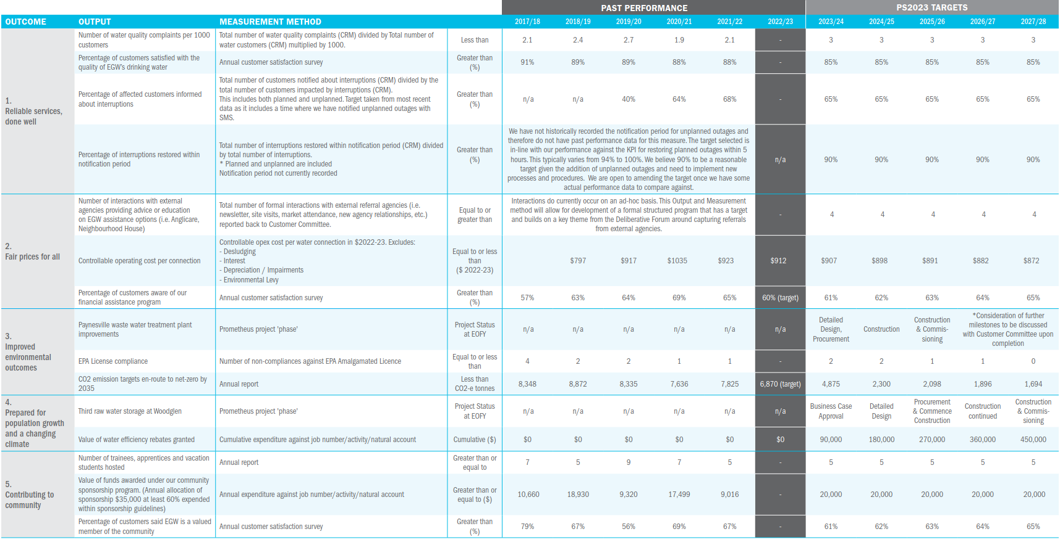

Appendix B: Guaranteed Service Levels
GSL | Comment
1. In the event of a sewage spill within a customer’s house, which is caused by us, there will be a $1,000 cash payment to the home-occupier affected. | The Customer Committee resolved that we keep this GSL and the rebate amount.
2. Will notify customers of planned interruptions to their water supply at least 48 hours in advance. If the organisation fails to do this, a rebate of $65 will be applied to the bills of affected customers. | The Customer Committee resolved that we keep this GSL and the rebate amount.
3. If a planned water supply interruption exceeds the period specified in the notice, affected customers will have a $65 rebate applied to their bill. | The Customer Committee resolved that we keep this GSL and the rebate amount.
4. We will not restrict a residential customer’s water supply or take legal action against the customer before all reasonable efforts have been made to contact them and provide information about help available if they are experiencing difficulties. *  If East Gippsland Water fails to do this, a rebate of $300 will be applied to the customer’s bill. | ESC mandated GSL. The Customer Committee resolved to retain the $300 rebate amount.
5. We are striving for net zero greenhouse gas emissions by 2035 and will provide a six-monthly update on progress against our targets to the community. There will be a written public apology if this update is not provided. | The Customer Committee resolved that we keep this GSL and the penalty of a public apology.
6. We have committed $90,000 each year from 2023-2028 to provide water efficiency rebates. This program will help customers reduce water consumption by providing incentives to save water. The program would encourage customers to claim rebates on possible water efficient products (dollar dependant). The allocation of funds for this project will be reported on at least annually. Any unspent money will be safeguarded for use only on the program. Any unspent funds at the end of the 5-year period will be allocated back to customers in the next price review. | The Customer Committee resolved that we replace the current native vegetation grants program with a water efficiency rebate program.  As an additional incentive it is proposed that any unspent funds at the end of the 5-year period will be allocated back to customers in the next price review.

