Getting to fair
  - Breaking down barriers to essential services
  - 12 August 2021

An appropriate citation for this paper is:
Essential Services Commission 2021, Getting to fair: Breaking down barriers to essential services, 12 August

Copyright notice
© Essential Services Commission, 2021

This work, Getting to fair, is licensed under a Creative Commons Attribution 4.0 licence [creativecommons.org/licenses/by/4.0]. You are free to re-use the work under that licence, on the condition that you credit the Essential Services Commission as author, indicate if changes were made and comply with the other licence terms.
The licence does not apply to any brand logo, images or photographs within the publication.

Message from the chairperson
“Vulnerability is not something you ‘are’. Vulnerability is something that can happen to anyone, at any time. “
This strategy has been almost two years in the making but it represents a shift that has been happening at the commission for the past five years.
The shift started in 2016 with our inquiry into energy hardship which found getting help with bills depended on which energy retailer you were with. The inquiry concluded that labelling people reinforced stigma, deterring people from reaching out for help until rising debt meant disconnection was inevitable.
We went on to develop Victoria’s nation-leading payment difficulties framework aimed at stopping the debt-disconnection cycle. The framework requires energy retailers to support customers who are struggling to pay their bills – without requiring them to prove they need help.
Then, in 2018 and 2019, we updated our customer service codes for water and energy to provide better protections for customers experiencing family violence following the royal commission.
The shift – to treating customers as people not passive recipients of essential services – is why we now have a plan to ensure our work supports access to essential services for consumers experiencing vulnerability.

People experiencing vulnerability are more likely to perceive barriers as insurmountable
Our strategy has been informed by the latest research and deep engagement with Victorians from right across the State, and all walks of life.
The research shows while anyone may perceive the barriers to accessing essential services, for those experiencing vulnerability, the barriers appear bigger and more daunting. They also feel less confident that they have the power to change things.
These barriers also tend to be cumulative, repeated across multiple services, compounding the stress and the harm.
To address this complexity, our strategy is built around three key objectives namely working with consumers, working with regulated businesses and working on ourselves. Each objective is underpinned by a series of actions to be further developed and implemented over the life of the strategy.

A work in progress – our shift continues
At its heart, the strategy aims to break down the barriers that block access to essential services. But the strategy is not to set and forget. We will continue to refine our approach over the next three years as we absorb new information and lessons learned and develop new capabilities.
We will monitor and report on our progress. We will adapt and evolve as new information and ideas become available.
‘Getting to fair’ is a shared pathway. To really make a difference for Victorians who may experience vulnerability at any time, we need to work with the wider community, the community help and advocacy services sector, the businesses we regulate and the government.
I am incredibly proud of this work and look forward to moving on to working together to deliver better results for all Victorians.
K SYMONS SIGNATURE
Kate Symons, Chairperson

Contents
Message from the chairperson ii
Contents iv
Why focus on the experience of vulnerability 5
Our strategic framework 7
How we developed our strategy 15
Next steps 17

Why focus on the experience of vulnerability
‘Getting to fair’ aims to break down the barriers consumers can face when accessing and engaging with essential services. It is a three-year roadmap for the commission to improve the experience of consumers facing vulnerability, by supporting our regulated and administered sectors to provide more responsive, inclusive and accessible services.
What this means for consumers
The social security system and a wide range of Victorian and Commonwealth services provide the primary supports to people experiencing vulnerability. But increasingly there is a recognition that businesses and regulators providing essential services also have a critical role to play. This is because the barriers that consumers experience are complex in nature and may require a multi-sector response.
Barriers can be temporary, long-term, or permanent, and consumers might be affected by multiple barriers at the same time. This could mean someone isn’t able to pay their bills, but it could also mean they can’t access information or support from their provider. What we have learnt during the development of this strategy is that we all have the potential to experience vulnerability, this could be due to:
- an event (e.g. job loss due to the pandemic, family violence or personal circumstances such as the death of a loved one)
- systemic factors (e.g. employment insecurity, lack of access in regional areas, lack of digital literacy or racism)
- features of the market (e.g. where information is too complex, or products and services aren’t designed with everyone in mind).
‘Getting to fair’ outlines the actions we will take to ensure all consumers, regardless of circumstances, have equitable access to the essential services we regulate and administer.
What we mean by vulnerability
Our definition of consumer vulnerability identifies barriers – rather than characteristics of the individual – as the biggest contributing factor in minimising access and engagement with essential services. With this definition we aim to highlight the role of regulators and business practice in supporting consumers. What we mean by vulnerability is outlined below.
A person experiencing, or at risk of experiencing, vulnerability is someone who experiences barriers to accessing or engaging in the essential services we regulate or administer. As a result of those barriers, that person experiences economic and/or social exclusion or harm. Barriers include event-based circumstances, systemic factors, and market-based factors.
The Essential Services Commission Act 2001 requires us to consider vulnerable and low-income consumers in our decision-making. However, our research showed that describing support as being ‘for the vulnerable’ can discourage people from seeking the help that’s available. We will continue to use the language of ‘consumers experiencing, or at risk of experiencing, vulnerability’ when communicating about our legislative functions. When communicating about customer issues we will use terms such as resilience, wellbeing, equity, accessibility, inclusion, and fairness.

Our strategic framework
The goal of our strategy is to break down barriers to essential services. This goal was identified based on what we heard through our research and engagement program.
The objectives give focus to the experience of consumers, the opportunities for our regulated sectors to reduce barriers to access and engagement in the services we regulate, and our own opportunities to be more inclusive, responsive and accessible.
The actions reflect the areas of work that will serve to address the three objectives and are supported by a focus on developing our own capability in two key areas: partnerships and coordination, and voice of the consumer.
Our strategic framework is presented in figure 1.

Strategic goal: Getting to fair, breaking down barriers to essential services
This strategy strives towards the goal of ‘Getting to fair: breaking down barriers to essential services’. This acknowledges that regulators need to play a greater role in empowering consumers to make choices and seek help when they need it, through breaking down barriers and facilitating equitable access to essential services. The strategy framework and a detailed description of the objectives are outlined in figure 1.
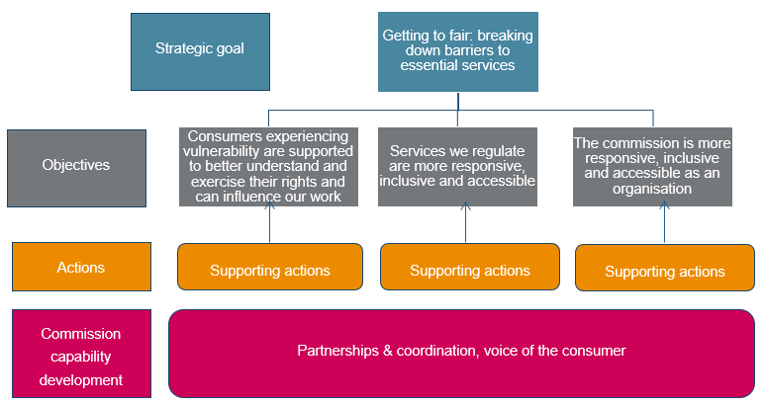
Figure 1: Our strategic framework

Objective 1: Consumers experiencing vulnerability are supported to better understand and exercise their rights and can influence our work
Consumers can engage with, and seek timely support from, providers of essential services if they understand their rights and how to access them. However this is not always the case. For instance, the Consumer Policy Research Centre found that 46 per cent of people seeking payment difficulty support had negative experiences when contacting their energy providers.
Research uncovered additional reasons why consumer rights may not be well understood, including:
- In the energy market, complexity coupled with inconsistent support from retailers eroded consumer trust and disempowered consumers from self-advocating.
- People are unsure how to or are unable to access information. Often, they do not trust the information provided by businesses. This is exacerbated for people whose first language is not English.
- A decrease in information and support available to First Nations consumers. This was due to the inability of services to go to communities and provide information during the coronavirus pandemic.
One of our community panel recommendations focused on awareness of consumer rights, entitlements, and obligations:
[the commission] work directly with consumers, and in partnership with organisations, to help educate consumers to become more aware of their rights, entitlements and obligations so that they are confident and empowered to understand, act and navigate the system with positive outcomes.
We are committed to supporting consumers to understand their rights better and have input into our work. Our actions outlined below aim to achieve this objective. These actions focus on capturing diverse consumer needs through developing and implementing processes for communication and relationship-building with consumer community groups, as well as direct engagement with consumers.

Objective 1 actions: Consumers experiencing vulnerability are supported to better understand and exercise their rights and influence our work
Over the next three years, we will take the following actions for objective 1.
Work collaboratively with our regulated sectors to support more effective and targeted engagement with diverse consumer and community groups, including:
on the effectiveness of family violence provisions currently in place across our regulated sectors
with energy retailers and distributors, particularly through the payment difficulty framework review
with water businesses in establishing prices, service standards and customer codes
explore opportunities to support intermediaries to advocate on behalf of their clients
to improve our engagement with groups representing consumers as part of our compliance and enforcement processes
on the Victorian Energy Upgrades’ engagement program
on the economic regulation of commercial passenger vehicles.
Develop a better understanding of First Nations consumers (acknowledging Aboriginal self-determination as a guiding principle). In doing so we will:
better understand the relationship First Nations people have with country
explore and adopt culturally appropriate ways for First Nations communities to directly guide and influence our work
support effective engagement between water businesses and their First Nations consumers and community through our regulatory role.
Pursue better practice communication and engagement in our work. Including:
investigate ways to build stronger relationships with diverse consumer groups as part of the review of our stakeholder engagement framework to ensure we hear from a variety of perspectives
improve consumer facing information to better meet the diverse needs of consumers, in understanding their rights, including in the Victorian Energy Upgrades program
address accessibility and inclusion of customer-facing information through the implementation of the digital strategy.
Include the voice of the consumer to better inform our work in:
Our reforms and monitoring of the energy market, including the effectiveness of the payment difficulty framework.
The outcomes of the review of the water customer service codes.
The effectiveness of family violence provisions currently in place across our regulated sectors, work in collaboration with the community and government stakeholders to promote better industry practice.

Objective 2: Services we regulate are more responsive, inclusive and accessible
To effectively identify and respond to the diverse needs of consumers experiencing, or at risk of experiencing vulnerability, service providers must be responsive, inclusive, and accessible.
However, research showed several examples where services and supports were not developed in an inclusive or responsive way, leading to inaccessible service provisions. This can be further complicated by people experiencing vulnerability needing to engage with essential services in different ways. Often, their engagement with services needs to reflect their individual circumstances, particularly at times of acute stress. This is usually done through trusted intermediaries, such as financial counsellors, community legal services, and community groups.
In dealing with inaccessible service provisions in the energy market, some customer support workers have resorted to hanging up and calling the retailer back until they find someone that can help. One support worker told the Consumer Policy Research Centre:
Halfway through the conversation, if they are not helpful, we hang up and call again because we will get someone more helpful ... Hang up and we will talk to someone who knows what they are talking about.
While many government support mechanisms were made available quickly during the coronavirus pandemic, we heard feedback from community sector workers that support measures did not always reach consumers most in need.
We are committed to working collaboratively with regulated sectors to build their capability to provide more responsive, inclusive and accessible services to all consumers. The actions outlined to achieve this objective focus on working collaboratively with regulated sectors to support a consistent understanding of vulnerability and improve consumer outcomes.

Objective 2 actions: Services we regulate are more responsive, inclusive and accessible
Over the next three years, we will take the following actions for objective 2.
Support better practice in delivering services to consumers experiencing vulnerability in our regulated sectors. Including:
a review of the effectiveness of the payment difficulty framework, focusing on implementation
enhancing outcomes for water consumers in our review of the water customer service codes
a review of the effectiveness of family violence provisions currently in place across our regulated sectors, and work in collaboration with community and government stakeholders to promote better industry practice
using industry education to support better practice approaches for energy retailers and distributors to have a consistent understanding of vulnerability, and how to better communicate with consumers experiencing barriers to access
supporting more universal and inclusive engagement practices by water businesses when preparing their submissions to us
working with accredited providers and the Department of Environment, Land, Water and Planning to expand the Victorian Energy Upgrades program to better reach diverse consumer groups
identifying and promoting best practice approaches to consumer outcomes through our collaborative work with the local government sector.
Include consideration of consumer vulnerability as an enduring priority in our compliance and enforcement work.
Monitor our regulated markets through qualitative and quantitative data to better understand how consumers experiencing vulnerability interact in the sectors we regulate.
Provide advice to government on consumers’ experience of vulnerability as it relates to our administered and regulated sectors.

Objective 3: The commission is more responsive, inclusive and accessible as an organisation
As the state’s economic regulator, we play a central role in achieving this strategy’s goal of ‘Getting to fair: breaking down barriers to essential services’. We are committed to building capability internally and within our regulated sectors so consumers who need support are identified and supported effectively and in a timely way.
Meeting the needs of diverse groups is key to providing appropriate communications to consumers – particularly in relation to support. Research shows consumers in need of support in essential services markets are not always identified in a timely manner, leading to a long-term experience of vulnerability. Research also shows that currently the diverse needs of Victorian consumers are often not met by businesses or regulators. For those experiencing vulnerability, language barriers can often cause or exacerbate harm, excluding consumers from seeking support. For instance, it was noted in one of our cross-sector workshops that awareness of the Utility Relief Grant Scheme remains low among those whose first language is not English.
The actions outlined to achieve this objective focus on developing a better understanding of the experience of vulnerability, how these consumers interact in the sectors we regulate, and on strengthening internal processes and procedures.
We acknowledge self-determination as the guiding principle in Aboriginal affairs. We recognise that self-determination involves more than consulting and partnering with Aboriginal Victorians on relevant policies and programs. We understand that there is a continuum that leads to Aboriginal self-determination, ranging from informing community through to transferring decision-making control. While we are at an early stage of advancing self-determination, we are committed to taking steps along this continuum.

Objective 3 actions: The commission is more responsive, inclusive and accessible as an organisation
Over the next three years, we will take the following actions for objective 3.
Demonstrate best practice as an organisation to be more responsive, inclusive, and accessible. Including:
promoting greater use of social procurement across the organisation
ensuring we are consistent in our approach to equity, access, and inclusion in recruitment and induction
building organisational capacity and awareness in using universal and inclusive engagement in our stakeholder engagement work
meeting our obligations under the Gender Equality Act 2020
develop a policy on when and how we remunerate participants in our engagement processes.
Develop a better understanding of First Nations Victorians (acknowledging Aboriginal self-determination as the guiding principle). In doing so we will:
develop and publish our plan to move from inclusion to self-determination
build cultural safety across the organisation.

Commission capability development
Work cutting across all objectives is critical to strengthening our engagement capability, ensures we involve the voice of consumers, and coordinate through partnerships.

Strengthening the voice of the consumer
This strategy aims to ensure the voices of consumers are better reflected in our work. Incorporating the voice of consumers in our work is integral for us to remain an effective and responsive regulator.
We are committed to improving consumer engagement. To do this, we will:
- bring together qualitative and quantitative data to better understand how consumers experiencing vulnerability are supported across the sectors we regulate
- listen to consumers and respond to their concerns.

Partnerships and coordination
Overwhelmingly, we heard more can be done to reduce the barriers that prevent consumers who are experiencing vulnerability from receiving the support they need. Coordination across regulators, governments, industry, and the community sector is the key to addressing these system-based issues.
Our community panel saw a distinct role for us in continuing to coordinate and build relationships across sectors to support systems change, and recommended we:
form active partnerships with relevant government, community and industry entities to take collective responsibility for consumers experiencing hardship. These partnerships will deliver tangible outcomes and systems improvement – delivering affordability, equity and accessibility – which are supported through internal and external accountability.
To this end, we will continue to play an active role in building relationships and bringing stakeholders and decision-makers together to address system-based issues in our regulated sectors.

How we developed our strategy
‘Getting to fair: Breaking down barriers to essential services’ was developed through an extensive research, engagement and capability building program. The development of this strategy is centred around the experience of consumers. The development of our strategy is presented in figure 2.

Research and engagement
We actively reached out to community representatives and advocates, including many we hadn’t engaged with before. We also consulted with a deliberative community panel (which represented a cross-section of the Victorian community), a stakeholder reference group, industry cross-sector workshops, and community sector roundtables.
Ensuring that we built a comprehensive understanding of barriers to accessing essential services, we also undertook an extensive research program, both commissioning our own work and reviewing other organisation’s reports.
Through these, we identified eight key areas of the consumer experience to provide a focus for our work.
- Consumers require appropriate, consistent and accessible communications.
- Consumer engagement needs to be universal and inclusive, leading to more accessible services.
- Consumer trust can be improved, to increase consumer empowerment and help to make choices or seek support.
- Consumers who need support should be identified quickly and supported effectively.
- Support offered to consumers should be consistent, helping ensure it is appropriate and flexible.
- Many First Nations consumers should receive better support and engagement to reduce their rates of disconnection.
- Government, industry and community organisations could coordinate more effectively to address issues across the system.
- Sudden, acute and unexpected challenges can have significant impact on consumers in the short, medium and long term.

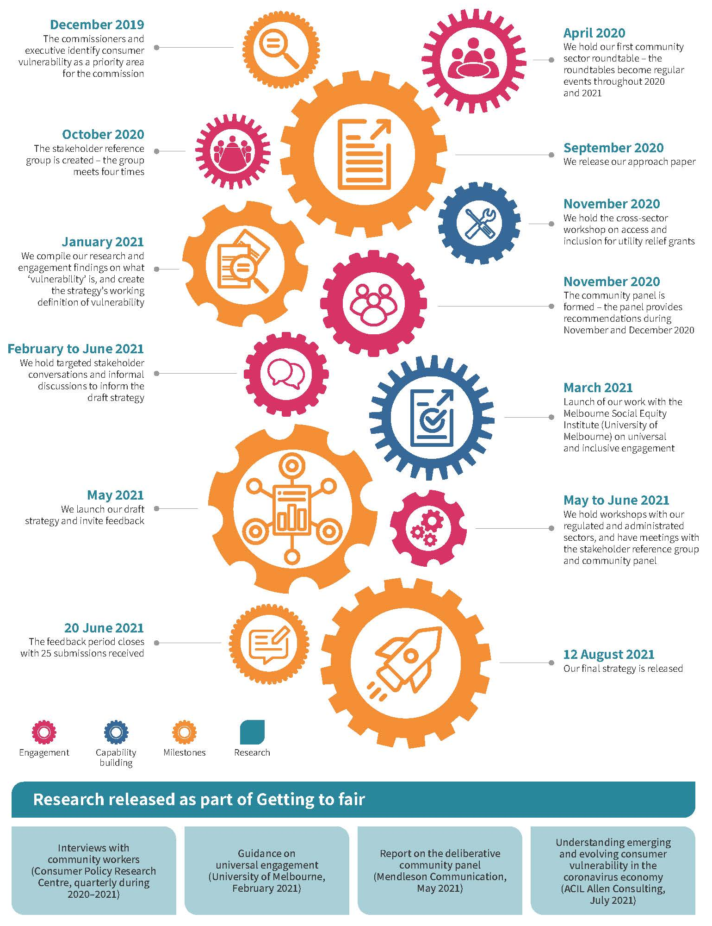
Figure 2: Developing our strategy

Next steps
This strategy will provide us with a pathway for the next three years. However, this is a living document – the start of an ongoing journey. We will be reviewing the strategy periodically to update it based on current and future needs.

Measurements of success
A key part of this strategy’s implementation will be the development of a measurement framework. The framework will ensure accountability and provide an understanding of how the actions have made progress towards the objectives.
Much of what this strategy aims to achieve is cultural change, so measuring its success will require collaboration. Throughout 2021–22 we will be working closely with our stakeholders to develop high-level aggregate measures of effect. Each action will have its own measure that is specific, measurable and timebound. Some actions – like the review of the payment difficulty framework – will have their own consultation period to ensure industry and community input. We will report back to stakeholders annually on the progress of our strategy.

Strategy timeframe
While this version of the strategy will be in place for three years, we are committed to annually reviewing its success and updating it to ensure the best possible outcome for consumers. It is intended to be a long-lasting program that will change and develop as our regulatory framework does. The possible actions make up the strategy reflect this timing, but some actions may continue beyond 2024 to suit the ongoing needs of their delivery.

Continuing engagement
We will continue to engage with regulated and administered businesses, consumers and community advocates, and other parts of government while this strategy is implemented. This will take the form of informal and formal consultation processes, events and actively building partnerships with government, businesses, and the community sector.

Contact us
If you have any questions, comments or would like further information, contact the team:
Consumer Vulnerability
Email: consumervulnerability@esc.vic.gov.au
Phone: (+61 3) 9032 1300 or 1300 664 969
Level 8, 570 Bourke Street
Melbourne, Victoria 3000

Consumer Policy Research Centre, ‘COVID-19 and Consumers: from crisis to recovery’, June 2020, p30.
Consumer Policy Research Centre, ‘Consumer experiences following energy market reforms in Victoria’ (quarter 2 report), interviews report for the Essential Services Commission, January 2021, p18.
Thriving Communities Partnership, ‘Disaster planning and recover collaborative research project, June 2020, p30.
Stakeholder reference group meeting, Essential Services Commission, held online, 3 December 2020.
Consumer Policy Research Centre, ‘Consumer experiences following energy market reforms in Victoria’ (quarter 4 final report), interviews report for the Essential Services Commission, June 2021, p4.
Community panel reflections, community panel meeting, Essential Services Commission, held online, 9 December 2020.

